Lenin on Immigration
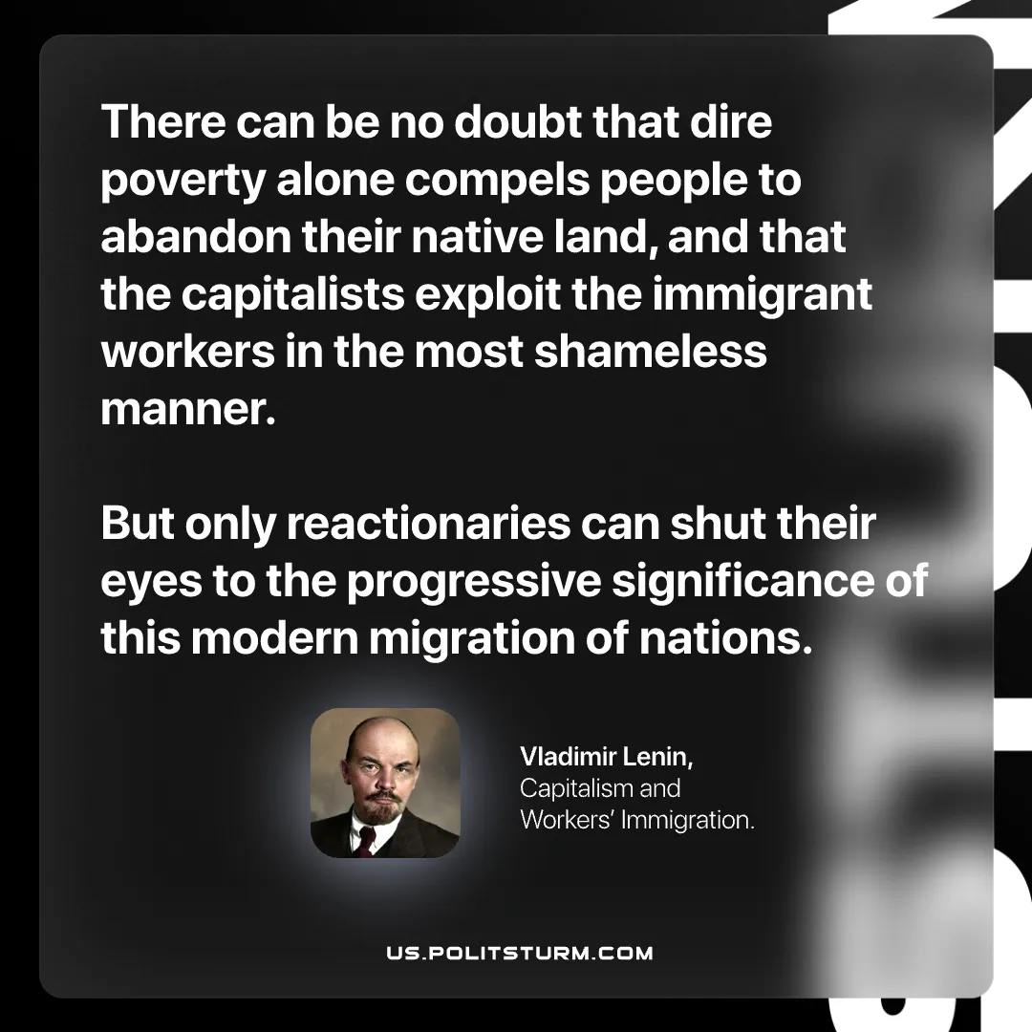

Original article
2026-07-26

There can be no doubt that dire poverty alone compels people to abandon their native land, and that the capitalists exploit the immigrant workers in the most shameless manner.
But only reactionaries can shut their eyes to the progressive significance of this modern migration of nations.
Vladimir Lenin, Capitalism and Workers' Immigration

Original article

