Lenin on Ideology
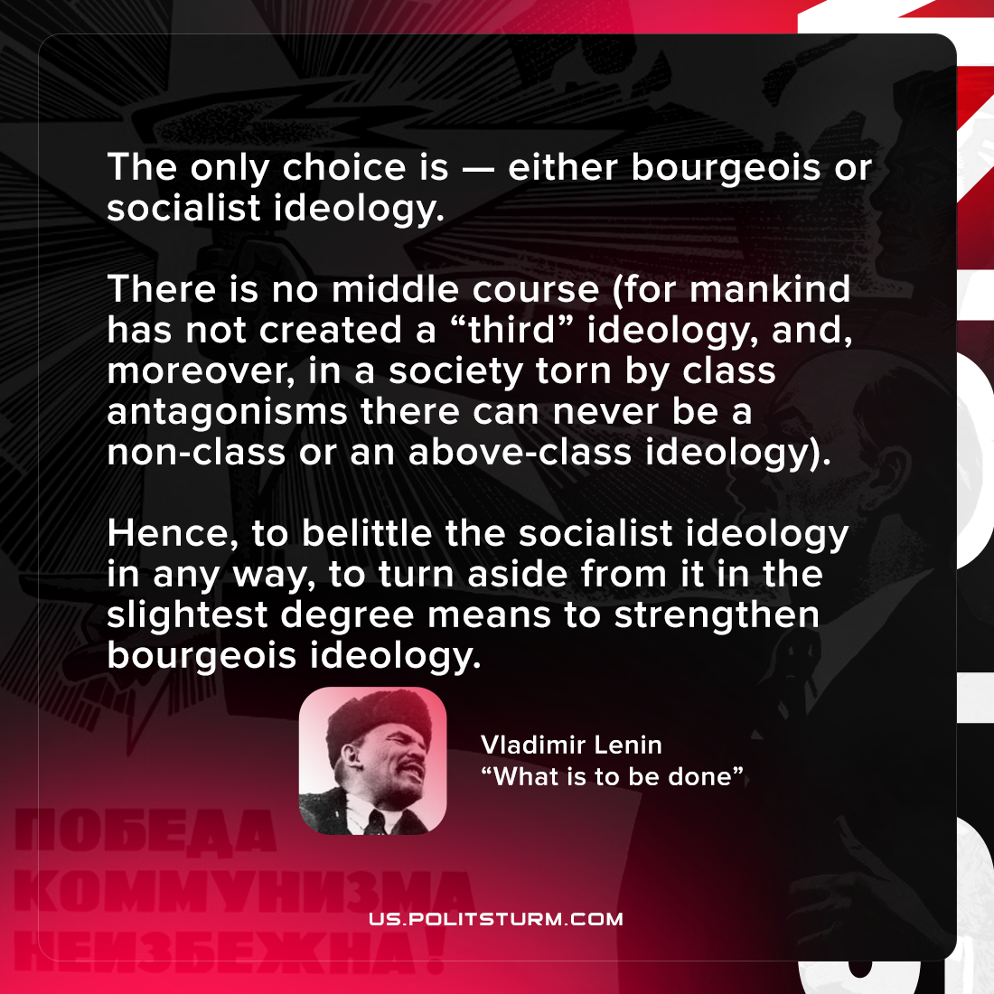

Original article
2021-10-20

The only choice is — either bourgeois or socialist ideology. There is no middle course (for mankind has not created a “third” ideology, and, moreover, in a society torn by class antagonisms there can never be a non-class or an above-class ideology). Hence, to belittle the socialist ideology in any way, to turn aside from it in the slightest degree means to strengthen bourgeois ideology

Vladimir Lenin, “What is to be done”

Original article

