Lenin on How Unity is Really Achieved
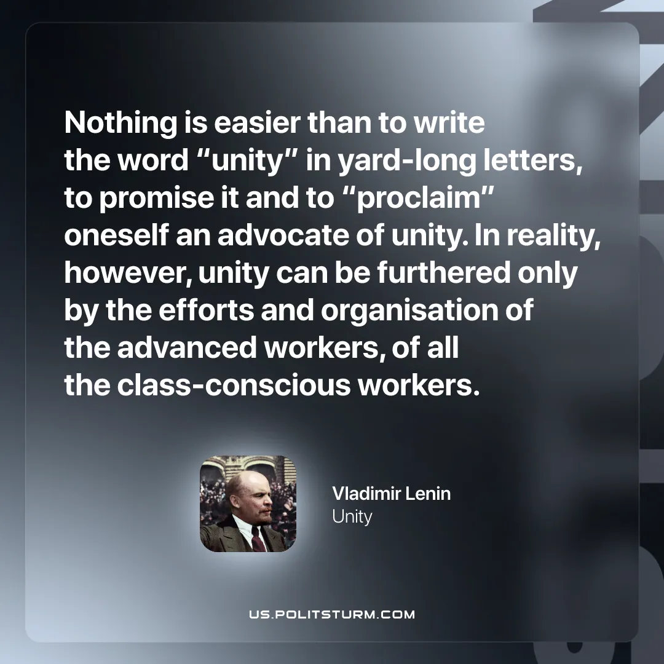

Original article
2026-04-19

”Nothing is easier than to write the word “unity” in yard-long letters, to promise it and to “proclaim” oneself an advocate of unity. In reality, however, unity can be furthered only by the efforts and organisation of the advanced workers, of all the class-conscious workers.”
Vladimir Lenin, Unity

Original article

