Lenin on how the Slogan of Unity With Opportunists Aids Reaction
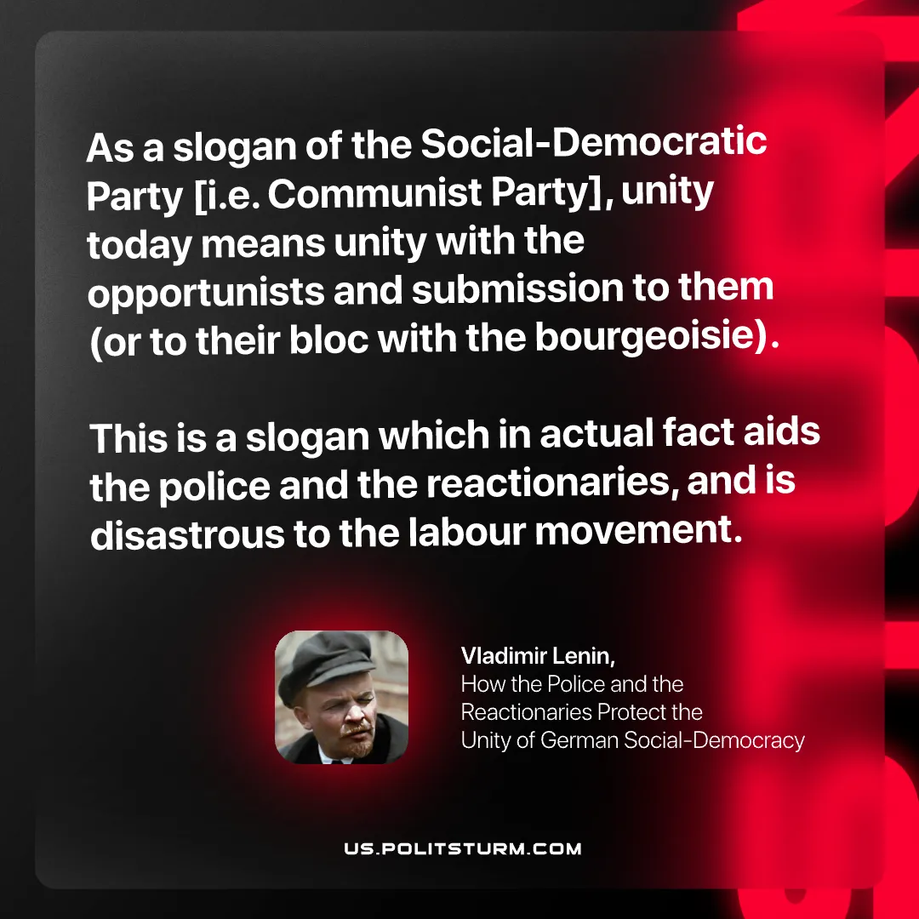

Original article
2025-09-20

“As a slogan of the Social-Democratic Party [i.e. Communist Party], unity today means unity with the opportunists and submission to them (or to their bloc with the bourgeoisie). This is a slogan which in actual fact aids the police and the reactionaries, and is disastrous to the labour movement.”
Vladimir Lenin, How the Police and the Reactionaries Protect the Unity of German Social-Democracy

Original article

