Lenin on How Strikes Teach Workers
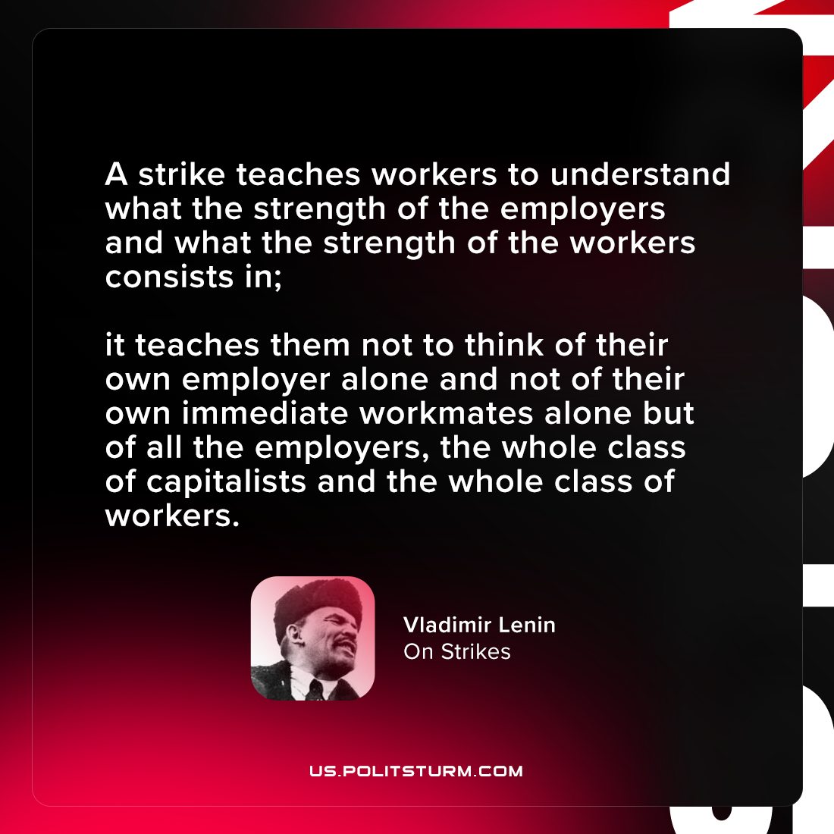

Original article
2021-08-09

A strike teaches workers to understand what the strength of the employers and what the strength of the workers consists in; it teaches them not to think of their own employer alone and not of their own immediate workmates alone but of all the employers, the whole class of capitalists and the whole class of workers.

Vladimir Lenin, “On Strikes”

Original article

