Lenin on how Reformism Weakens the Working Class
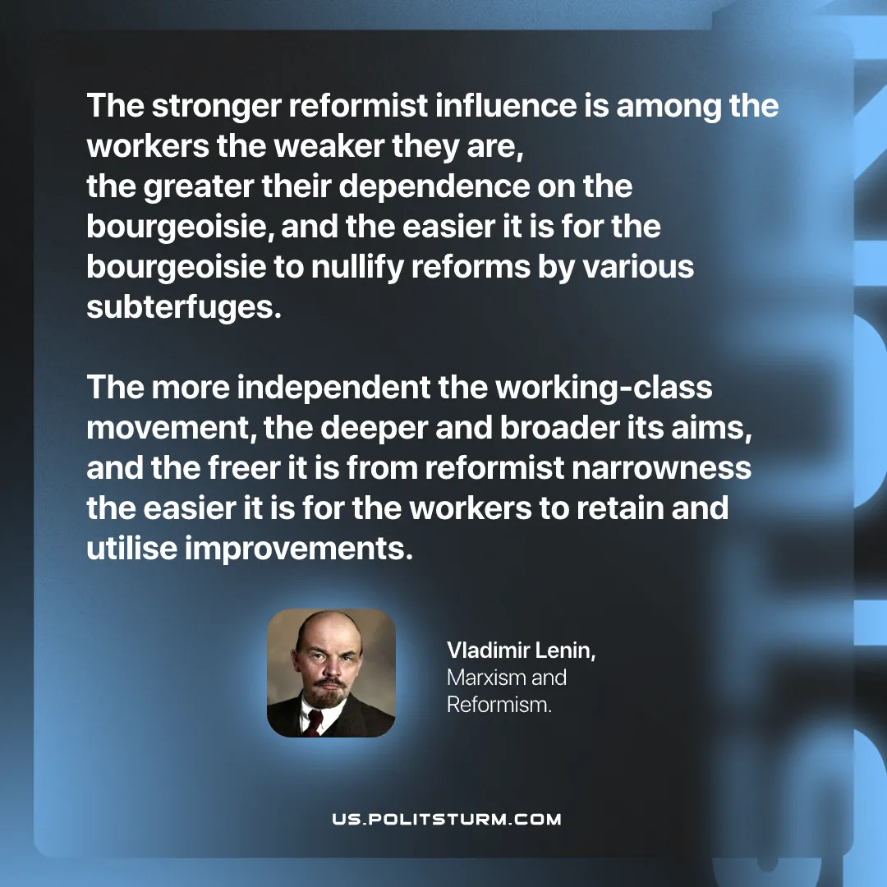

Original article
2026-08-01

The stronger reformist influence is among the workers the weaker they are, the greater their dependence on the bourgeoisie, and the easier it is for the bourgeoisie to nullify reforms by various subterfuges.
The more independent the working‑class movement, the deeper and broader its aims, and the freer it is from reformist narrowness the easier it is for the workers to retain and utilise improvements.
Vladimir Lenin, Marxism and Reformism

Original article

