Lenin on how Peaceful Alliances Lead to Wars
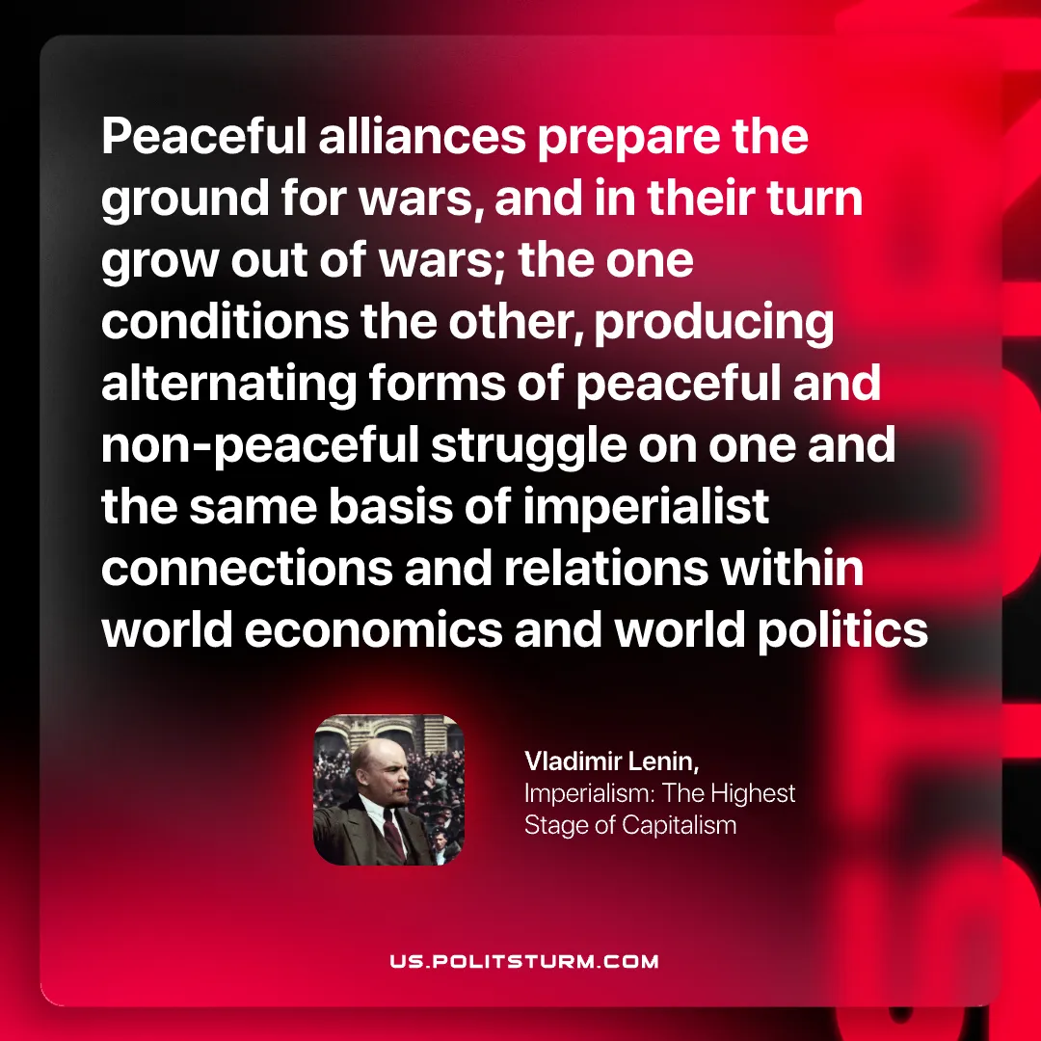

Original article
2026-02-28

“Peaceful alliances prepare the ground for wars, and in their turn grow out of wars; the one conditions the other, producing alternating forms of peaceful and non-peaceful struggle on one and the same basis of imperialist connections and relations within world economics and world politics”
Vladimir Lenin, Imperialism: The Highest Stage of Capitalism

Original article

