Lenin on how Opportunism Expresses Capitalist Policy and Interests
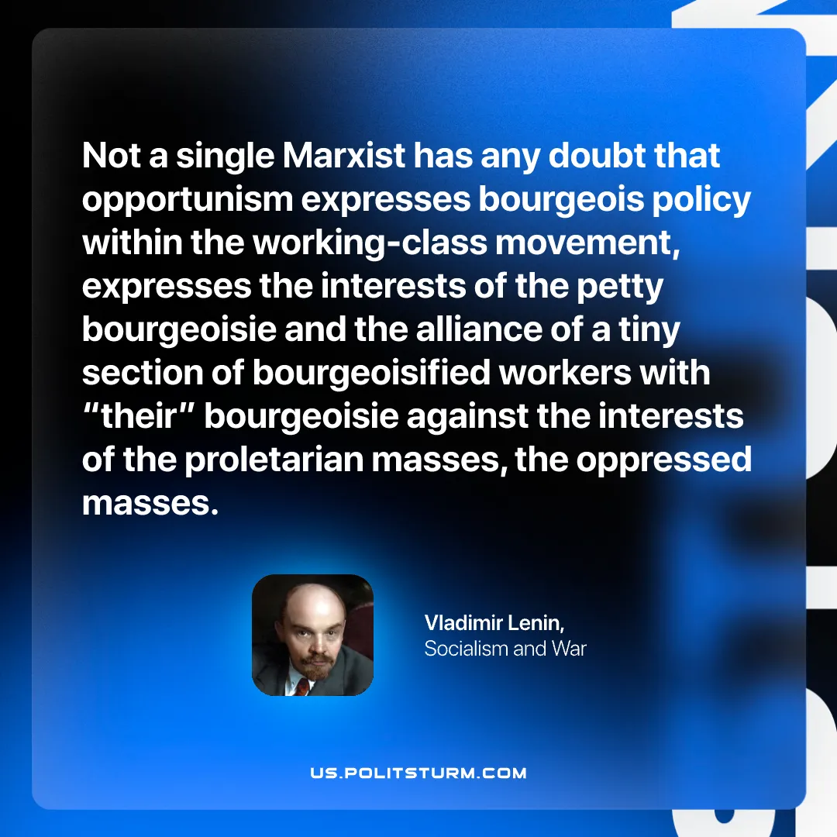

Original article
2026-02-17

“Not a single Marxist has any doubt that opportunism expresses bourgeois policy within the working-class movement, expresses the interests of the petty bourgeoisie and the alliance of a tiny section of bourgeoisified workers with “their” bourgeoisie against the interests of the proletarian masses, the oppressed masses.”
Vladimir Lenin, Socialism and War

Original article

