Lenin on How Monopoly Gives Way to Reaction
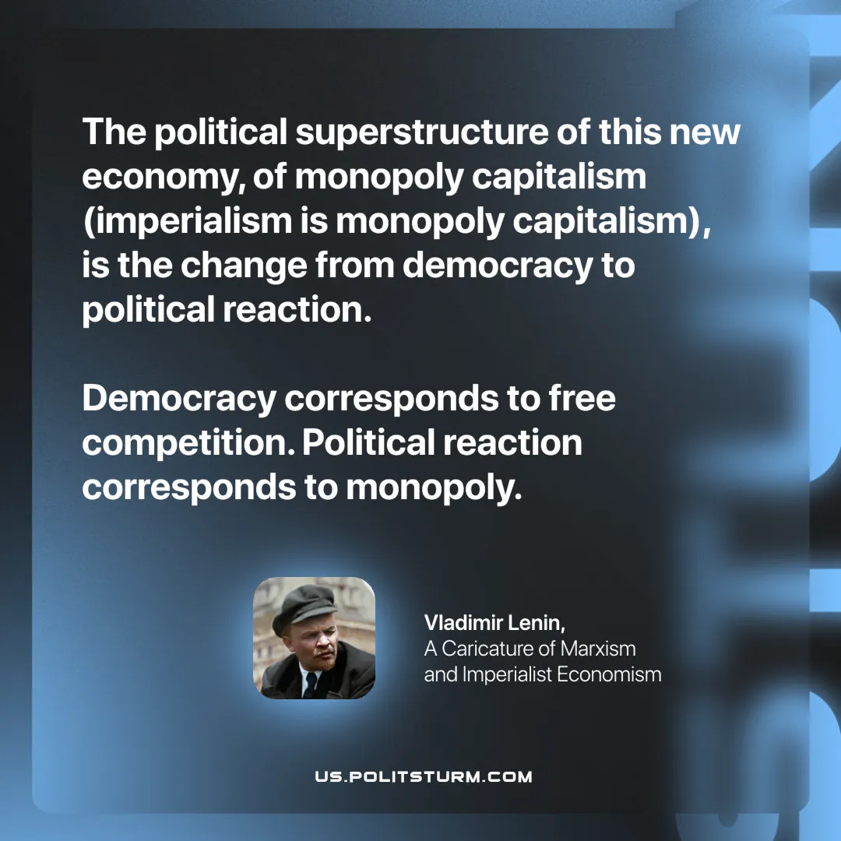

Original article
2025-08-05

“The political superstructure of this new economy, of monopoly capitalism (imperialism is monopoly capitalism), is the change from democracy to political reaction. Democracy corresponds to free competition. Political reaction corresponds to monopoly.
Vladimir Lenin, A Caricature of Marxism and Imperialist Economism

Original article

