Lenin on how Keeping Capitalism Makes Peace Impossible
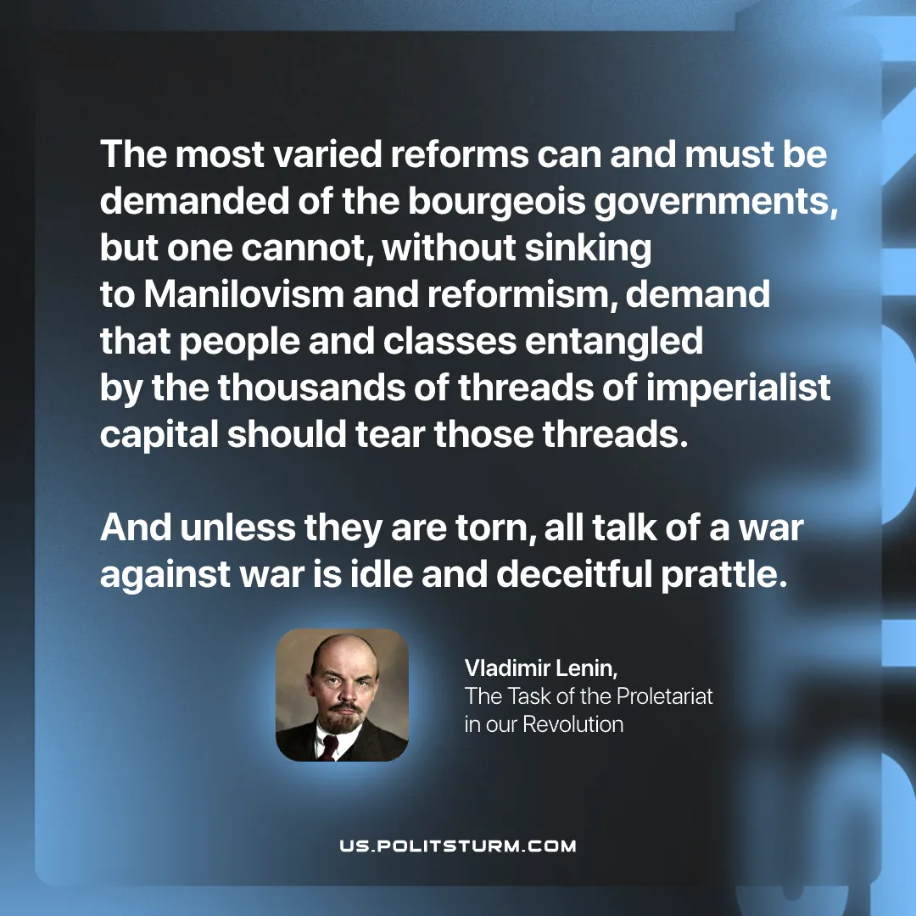

Original article
2026-02-15

“The most varied reforms can and must be demanded of the bourgeois governments, but one cannot, without sinking to Manilovism and reformism, demand that people and classes entangled by the thousands of threads of imperialist capital should tear those threads. And unless they are torn, all talk of a war against war is idle and deceitful prattle.”
Vladimir Lenin, The Task of the Proletariat in our Revolution

Original article

