Lenin on how Innovation Under Capitalism Leads Workers to Ruin
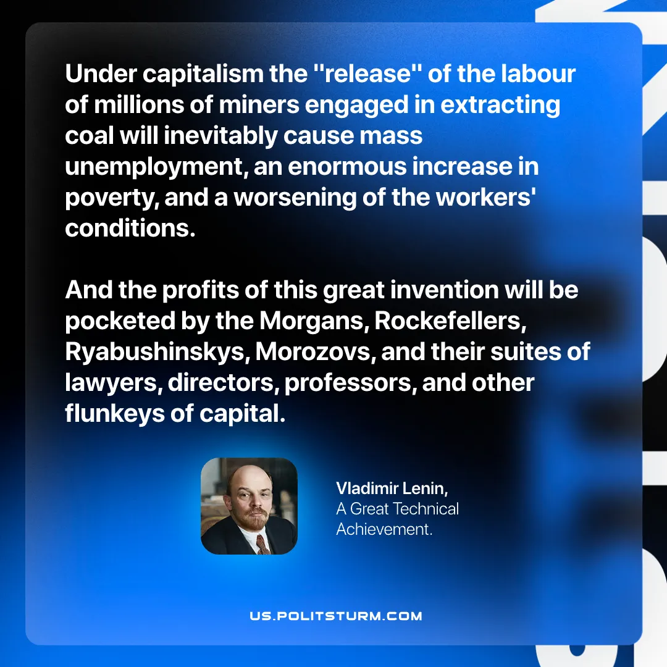

Original article
2026-07-14

Under capitalism the "release" of the labour of millions of miners engaged in extracting coal will inevitably cause mass unemployment, an enormous increase in poverty, and a worsening of the workers' conditions.
And the profits of this great invention will be pocketed by the Morgans, Rockefelleres, Ryabushinskys, Morozovs, and their suites of lawyers, directors, professors, and other flunkeys of capital.
Vladimir Lenin, A Great Technical Achievement

Original article

