Lenin on how Imperialism Works as an International System of Oppression
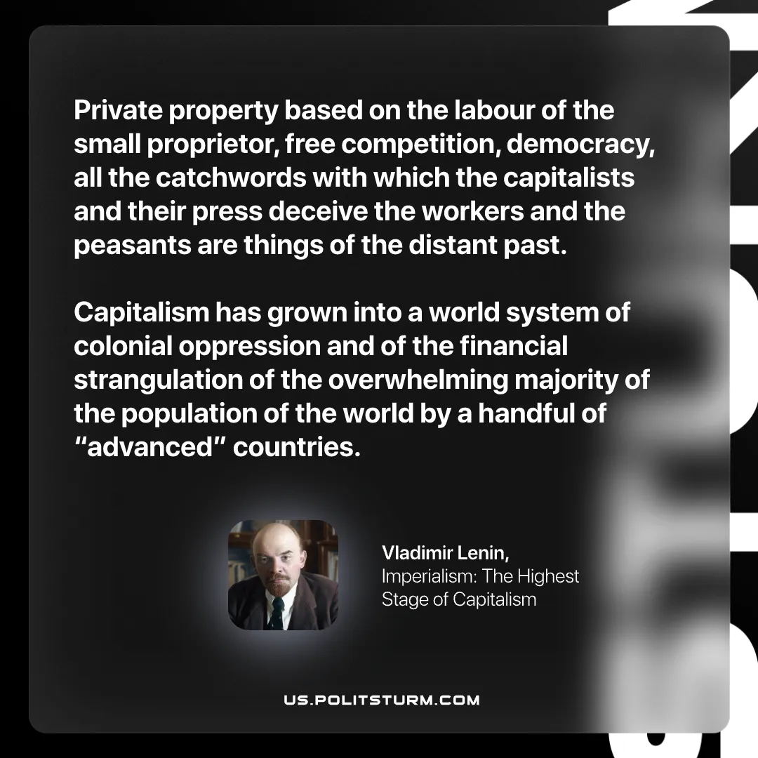

Original article
2026-02-07

“Private property based on the labour of the small proprietor, free competition, democracy, all the catchwords with which the capitalists and their press deceive the workers and the peasants are things of the distant past. Capitalism has grown into a world system of colonial oppression and of the financial strangulation of the overwhelming majority of the population of the world by a handful of “advanced” countries.”
Vladimir Lenin, Imperialism: The Highest Stage of Capitalism

Original article

