Lenin on How Crises Reveal Issues
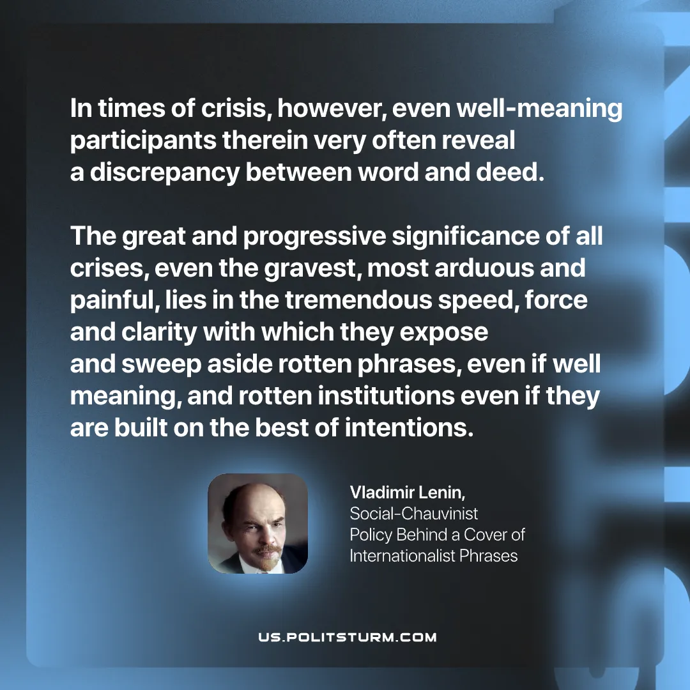

Original article
2026-01-01

“In times of crisis, however, even well-meaning participants therein very often reveal a discrepancy between word and deed. The great and progressive significance of all crises, even the gravest, most arduous and painful, lies in the tremendous speed, force and clarity with which they expose and sweep aside rotten phrases, even if well meaning, and rotten institutions even if they are built on the best of intentions.”
Vladimir Lenin, Social-Chauvinist Policy Behind A Cover Of Internationalist Phrases

Original article

