Lenin on how Capitalists Weaken the Revolutionary Movement
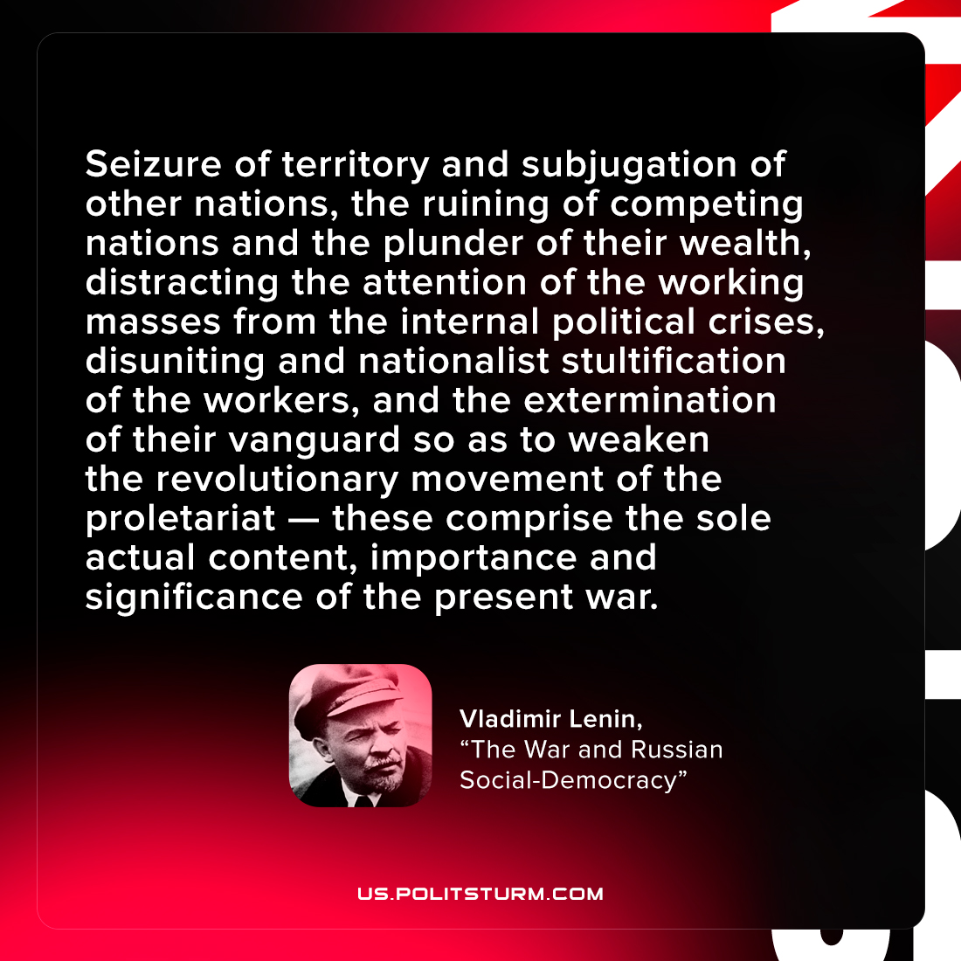

Original article
2022-02-26

Seizure of territory and subjugation of other nations, the ruining of competing nations and the plunder of their wealth, distracting the attention of the working masses from the internal political crises, disuniting and nationalist stultification of the workers, and the extermination of their vanguard so as to weaken the revolutionary movement of the proletariat — these comprise the sole actual content, importance and significance of the present war.

Vladimir Lenin, “The War and Russian Social-Democracy”

Original article

