Lenin on how Capitalism Improves at the Expense of the Workers
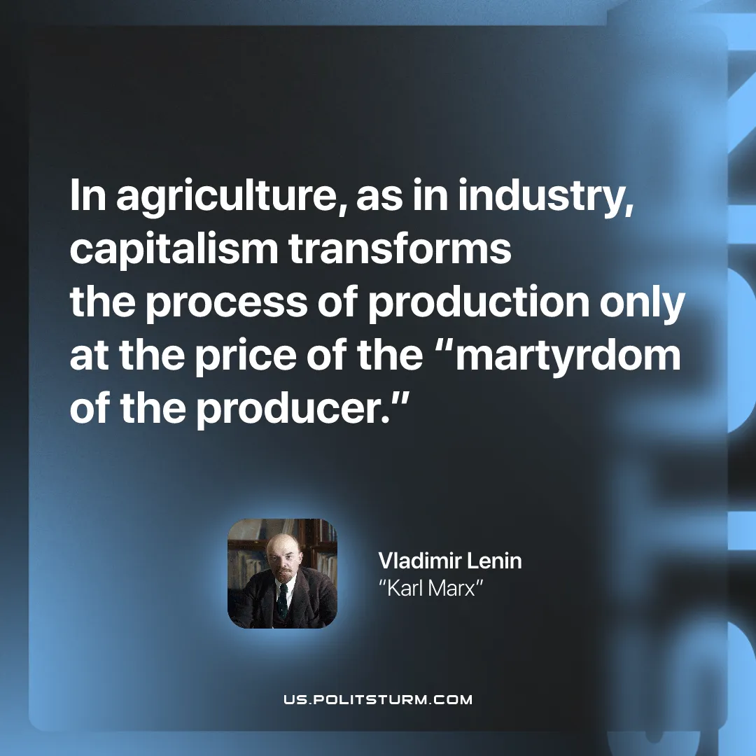

Original article
2026-02-03

“In agriculture, as in industry, capitalism transforms the process of production only at the price of the “martyrdom of the producer.”
Vladimir Lenin, “Karl Marx”

Original article

