Lenin on how Capitalism can use any Government Structure
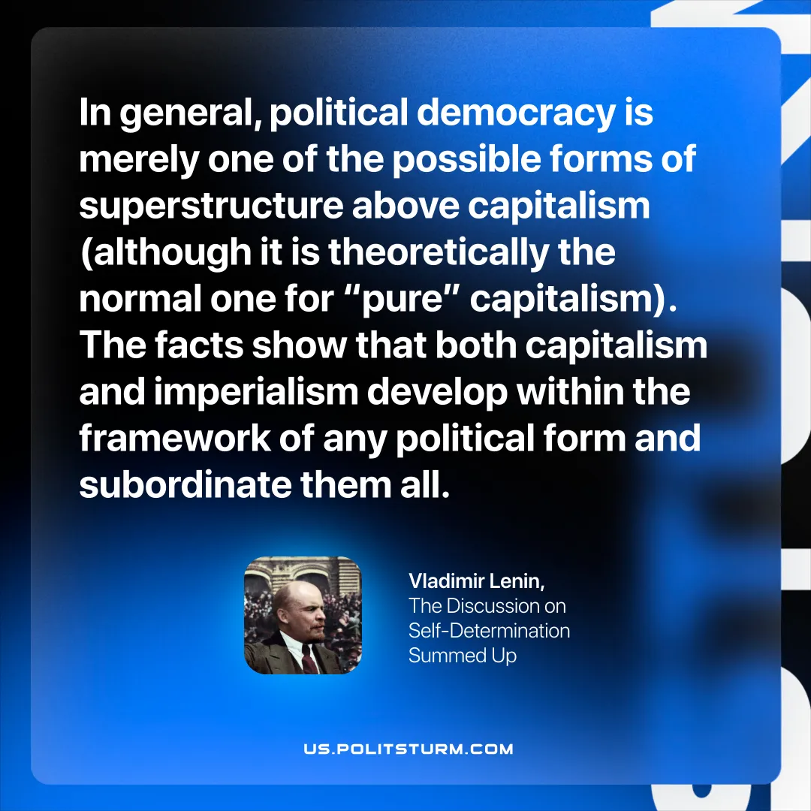

Original article
2026-03-22

“In general, political democracy is merely one of the possible forms of superstructure above capitalism (although it is theoretically the normal one for “pure” capitalism). The facts show that both capitalism and imperialism develop within the framework of any political form and subordinate them all.”Vladimir Lenin, The Discussion on Self-Determination Summed Up

Original article

