Lenin on how Capitalism Became the new System of Oppression
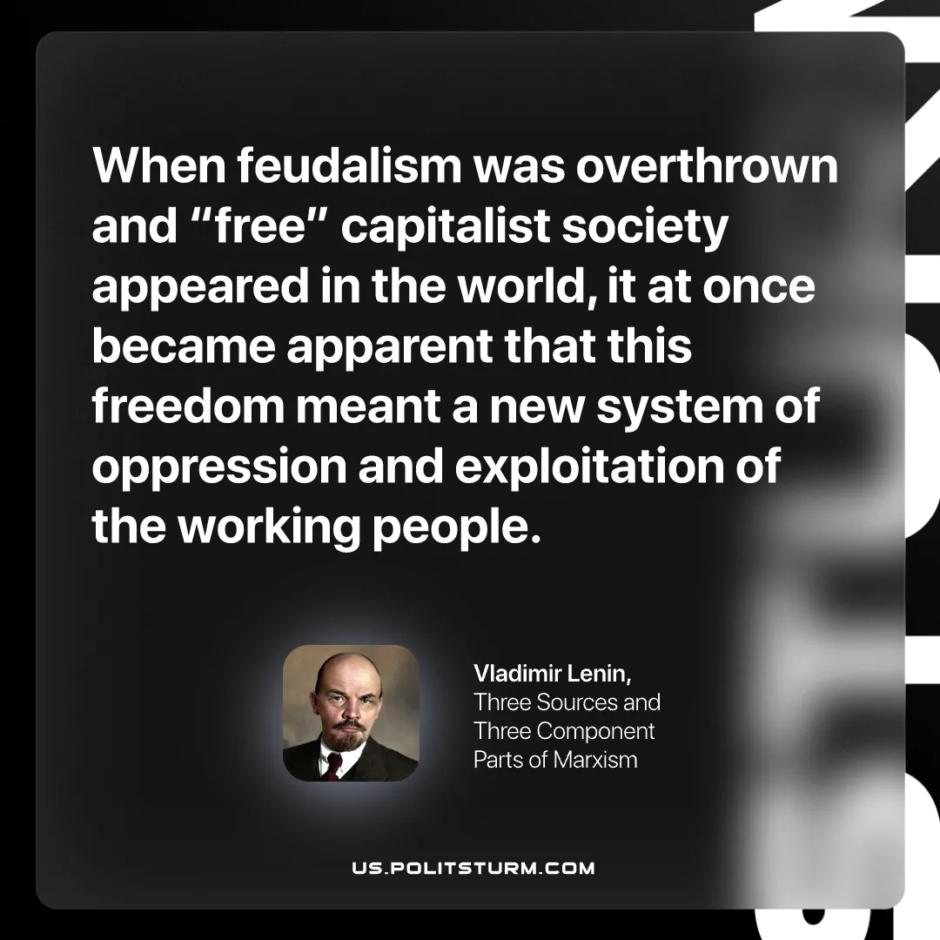

Original article
2026-02-14

“When feudalism was overthrown and “free” capitalist society appeared in the world, it at once became apparent that this freedom meant a new system of oppression and exploitation of the working people.”
Vladimir Lenin, Three Sources and Three Component Parts of Marxism

Original article

