Lenin on how Capital Corrupts Even the Most Democratic Republics
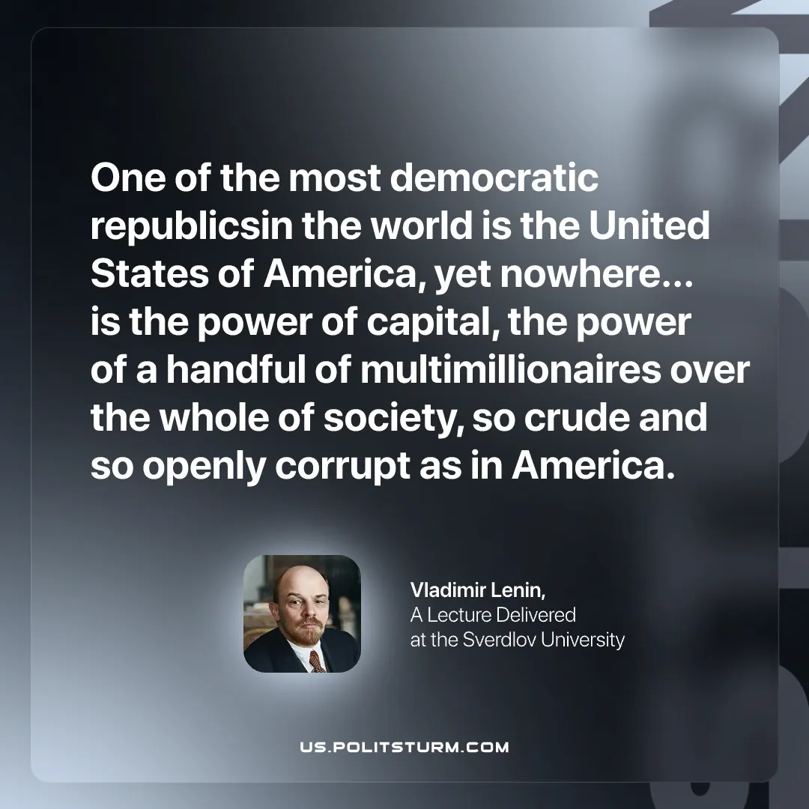

Original article
2026-02-19

“One of the most democratic republics in the world is the United States of America, yet nowhere… is the power of capital, the power of a handful of multimillionaires over the whole of society, so crude and so openly corrupt as in America.”
Vladimir Lenin, A Lecture Delivered at the Sverdlov University

Original article

