Lenin on how Capital Controls the State
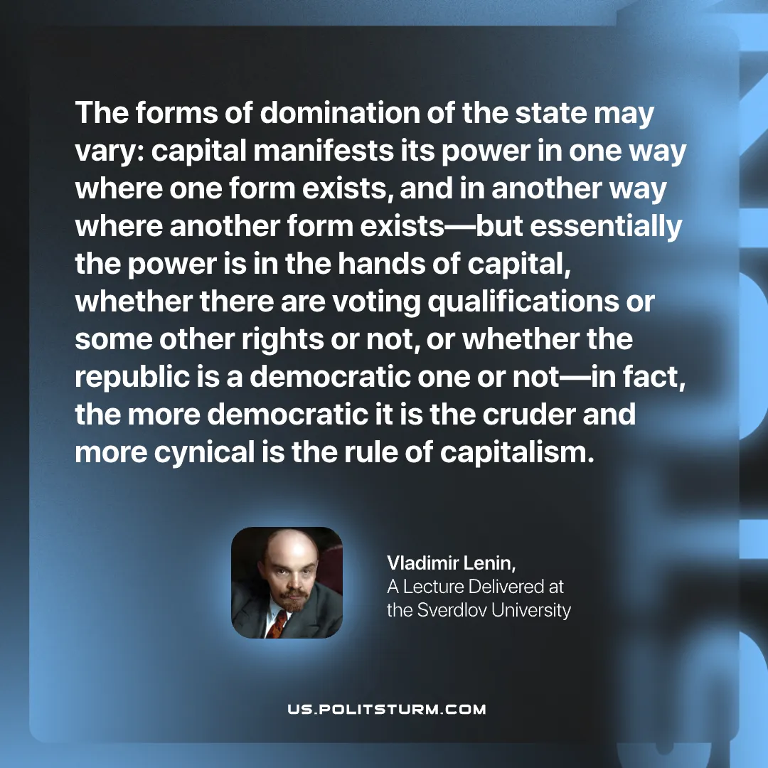

Original article
2026-02-24

“The forms of domination of the state may vary: capital manifests its power in one way where one form exists, and in another way where another form exists—but essentially the power is in the hands of capital, whether there are voting qualifications or some other rights or not, or whether the republic is a democratic one or not—in fact, the more democratic it is the cruder and more cynical is the rule of capitalism.”
Vladimir Lenin, A Lecture Delivered at the Sverdlov University

Original article

