Lenin on how a Small Capitalist Class Oppresses the Working Masses
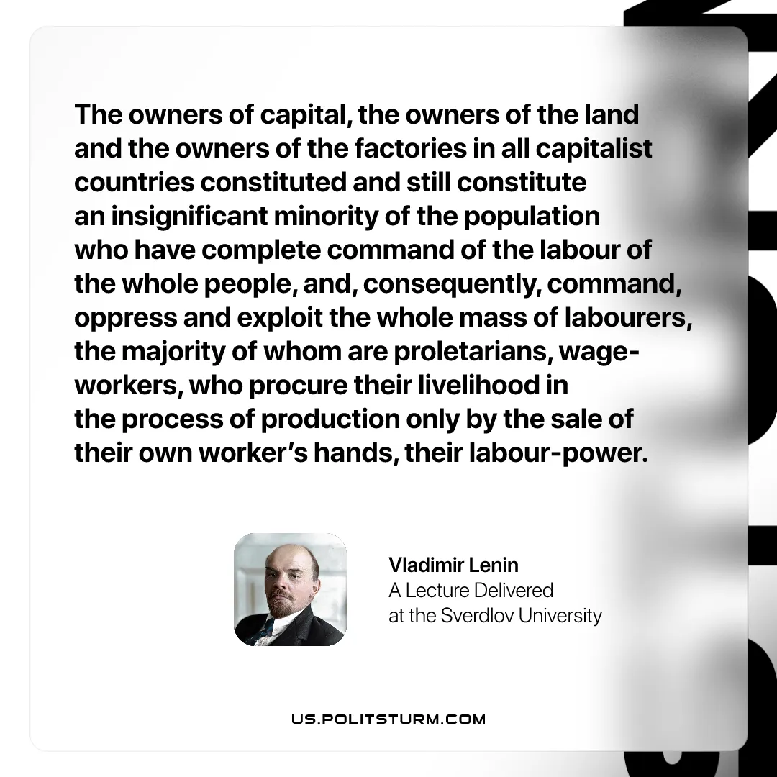

Original article
2026-02-05
1 min read

“The owners of capital, the owners of the land and the owners of the factories in all capitalist countries constituted and still constitute an insignificant minority of the population who have complete command of the labour of the whole people, and, consequently, command, oppress and exploit the whole mass of labourers, the majority of whom are proletarians, wage-workers, who procure their livelihood in the process of production only by the sale of their own worker’s hands, their labour-power.”
Vladimir Lenin, A Lecture Delivered at the Sverdlov University

Original article

