Lenin on how a Newspaper functions as a Collective Organizer
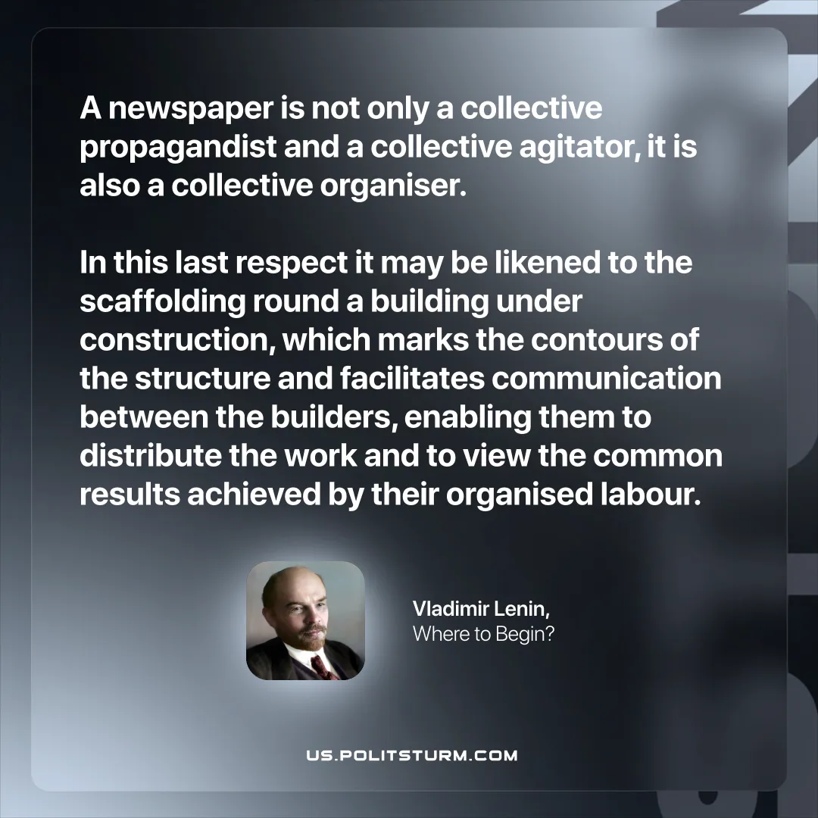

Original article
2025-10-12

“A newspaper is not only a collective propagandist and a collective agitator, it is also a collective organiser. In this last respect it may be likened to the scaffolding round a building under construction, which marks the contours of the structure and facilitates communication between the builders, enabling them to distribute the work and to view the common results achieved by their organised labour.”
Vladimir Lenin, Where to Begin?

Original article

