Lenin on "Healthy" Capitalism
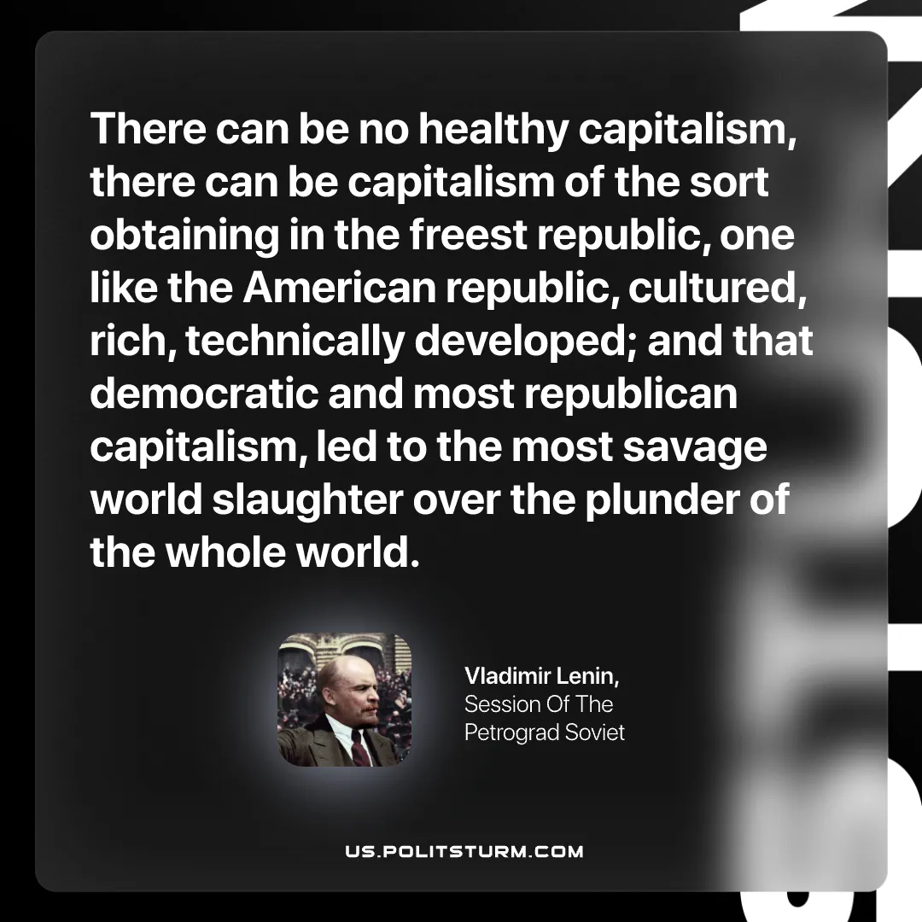

Original article
2026-10-13

There can be no healthy capitalism, there can be capitalism of the sort obtaining in the freest republic, one like the American republic, cultured, rich, technically developed; and that democratic and most republican capitalism, led to the most savage world slaughter over the plunder of the whole world.
Vladimir Lenin, Session Of The Petrograd Soviet

Original article

