Lenin on Hardship of Revolution
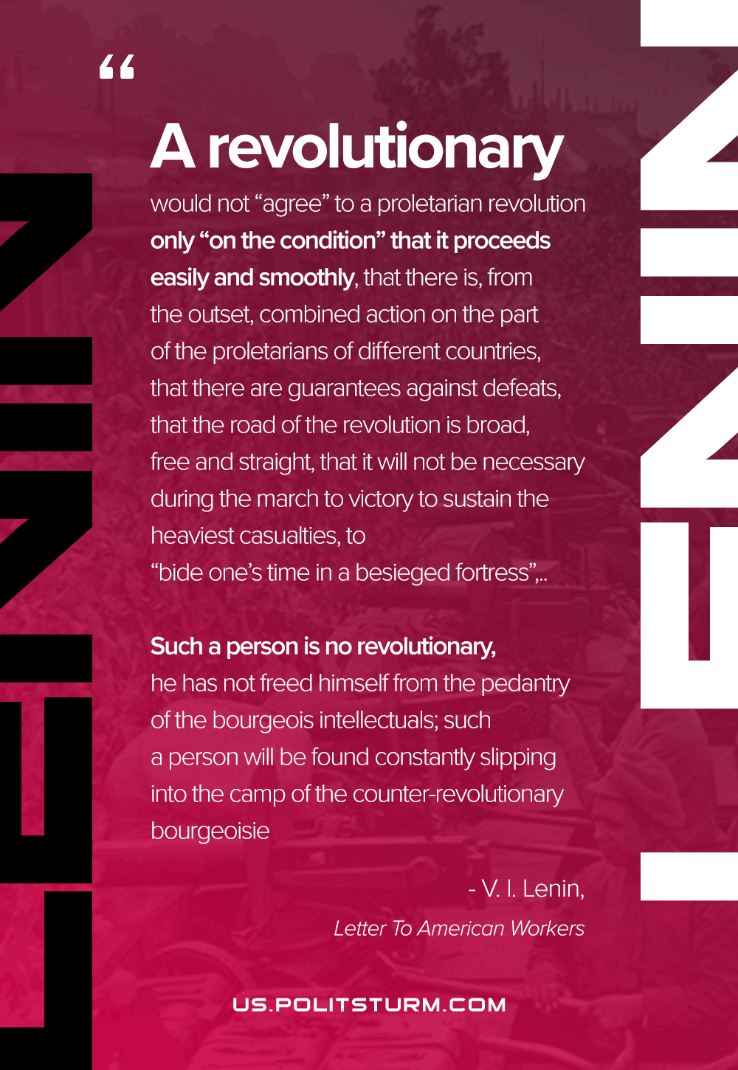

Original article
2021-05-04
1 min read

A revolutionary would not “agree” to a proletarian revolution only “on the condition” that it proceeds easily and smoothly, that there is, from the outset, combined action on the part of the proletarians of different countries, that there are guarantees against defeats, that the road of the revolution is broad, free and straight, that it will not be necessary during the march to victory to sustain the heaviest casualties, to “bide one’s time in a besieged fortress”, or to make one’s way along extremely narrow, impassable, winding and dangerous mountain tracks. Such a person is no revolutionary, he has not freed himself from the pedantry of the bourgeois intellectuals; such a person will be found constantly slipping into the camp of the counter-revolutionary bourgeoisie…
Letter To American Workers

Original article

