Lenin on Half-Measures
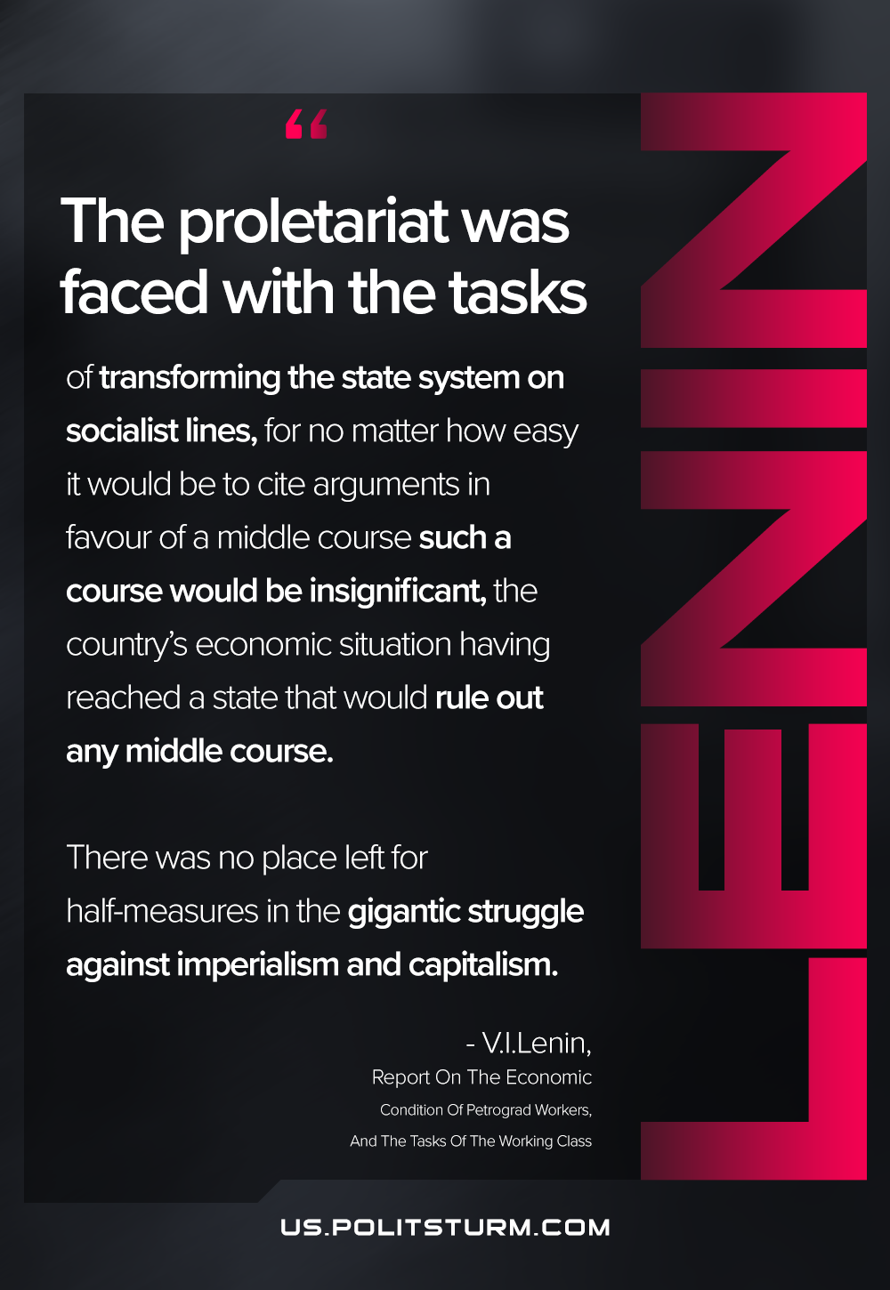

Original article
2021-04-19
1 min read

The proletariat was faced with the tasks of transforming the state system on socialist lines, for no matter how easy it would be to cite arguments in favour of a middle course such a course would be insignificant, the country’s economic situation having reached a state that would rule out any middle course. There was no place left for half-measures in the gigantic struggle against imperialism and capitalism.
Report On The Economic Condition Of Petrograd Workers And The Tasks Of The Working Class

Original article

