Lenin on Freedom of Discussion and Unity of Action Fighting Harmful Tendencies
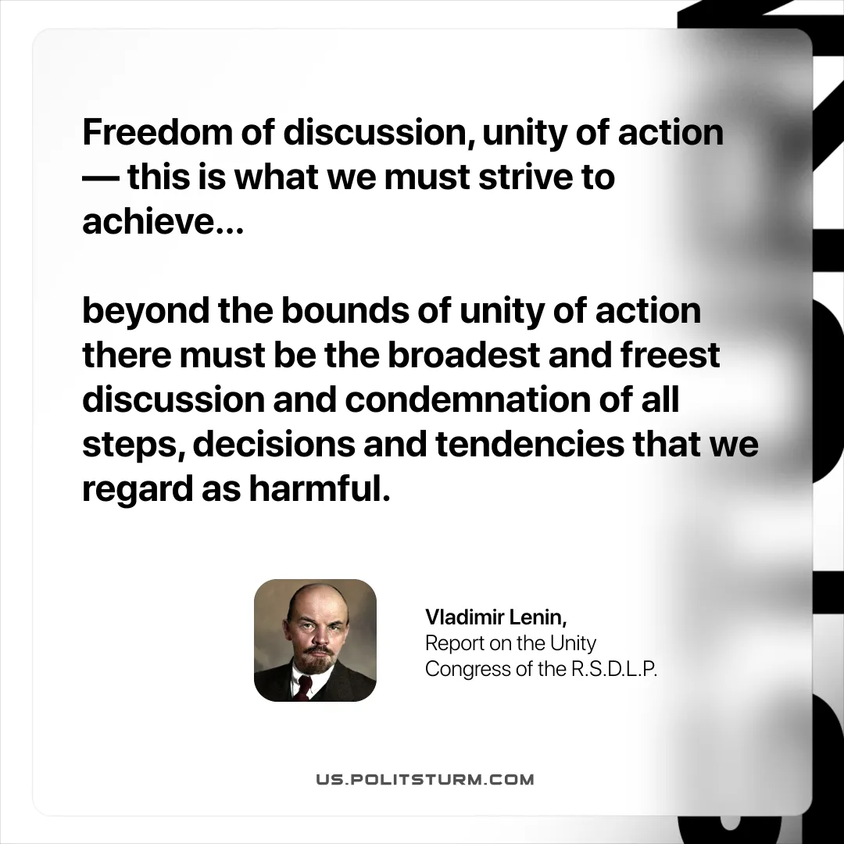

Original article
2025-12-06

“Freedom of discussion, unity of action — this is what we must strive to achieve… beyond the bounds of unity of action there must be the broadest and freest discussion and condemnation of all steps, decisions and tendencies that we regard as harmful.”
Vladimir Lenin, Report on the Unity Congress of the R.S.D.L.P.

Original article

