Lenin on “Free” Capitalist Society
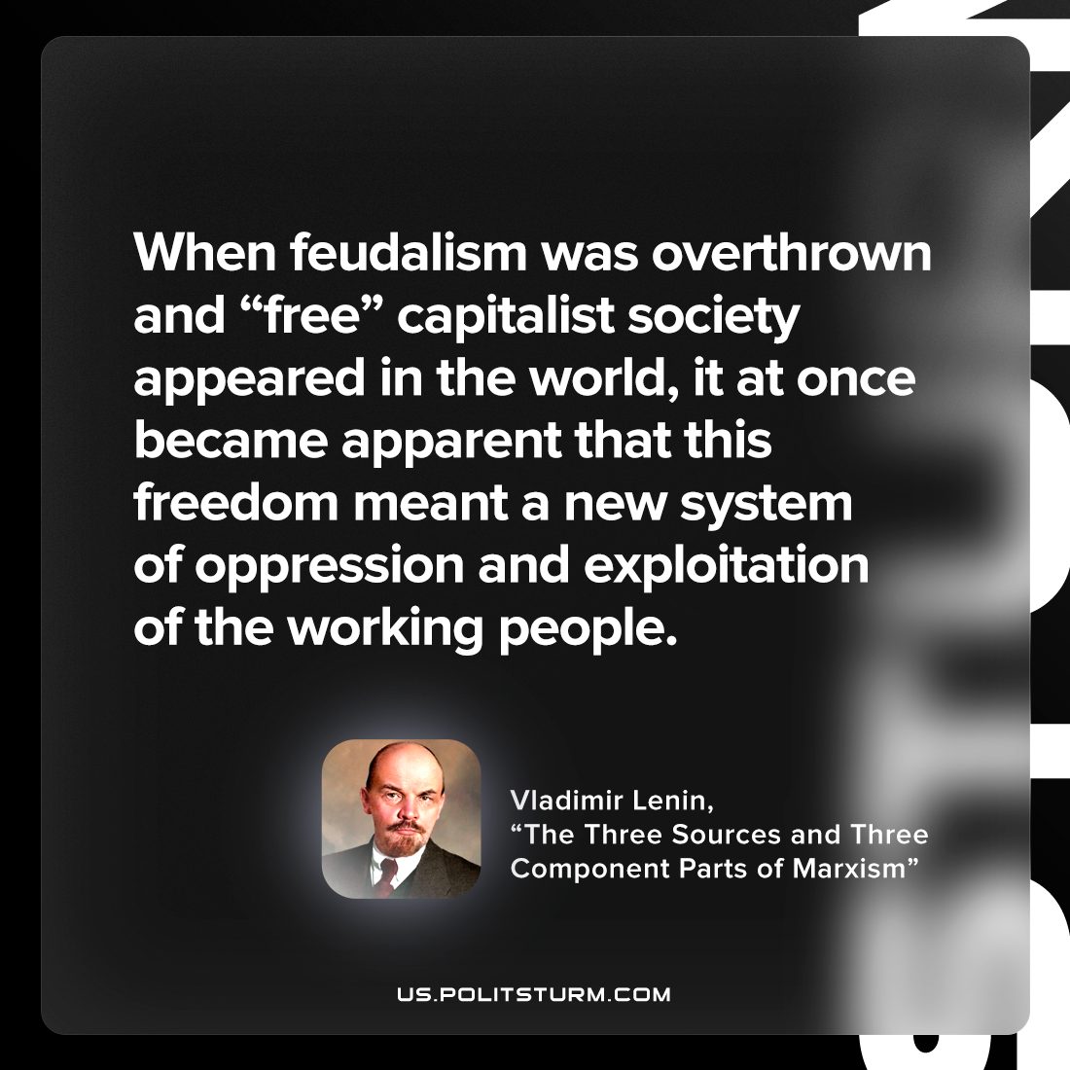

Original article
2023-02-19

"When feudalism was overthrown and “free” capitalist society appeared in the world, it at once became apparent that this freedom meant a new system of oppression and exploitation of the working people."
Vladimir Lenin, "The Three Sources and Three Component Parts of Marxism"

Original article

