Lenin on Foundations of Capitalism and Imperialism
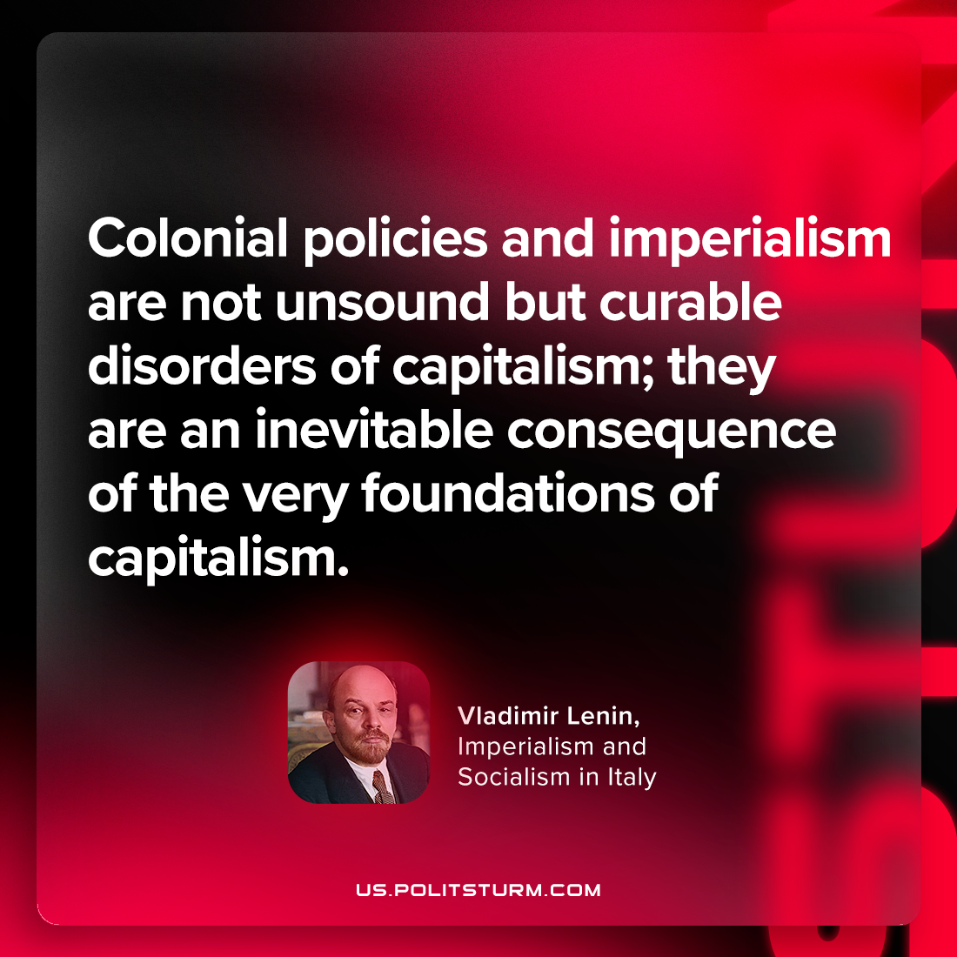

Original article
2023-04-06

"Colonial policies and imperialism are not unsound but curable disorders of capitalism; they are an inevitable consequence of the very foundations of capitalism."
Vladimir Lenin, “Imperialism and Socialism in Italy”

Original article

