Lenin on Forms of Government
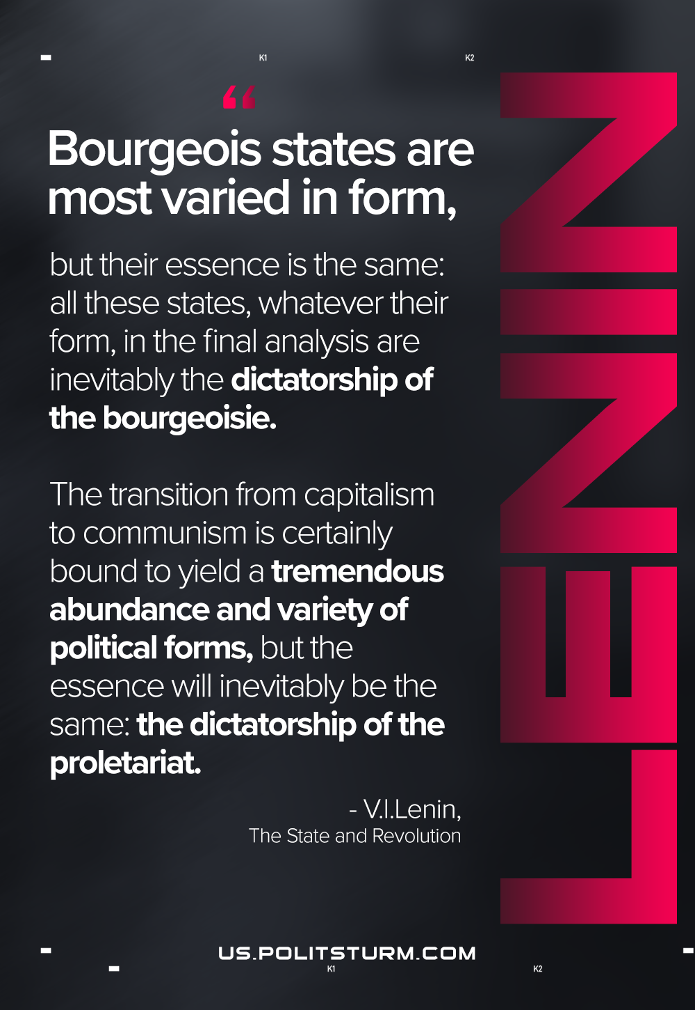

Original article
2021-05-24

Bourgeois states are most varied in form, but their essence is the same: all these states, whatever their form, in the final analysis are inevitably the dictatorship of the bourgeoisie. The transition from capitalism to communism is certainly bound to yield a tremendous abundance and variety of political forms, but the essence will inevitably be the same: the dictatorship of the proletariat.
Lenin, State and Revolution

Original article

