Lenin on Following the Class Interest Behind Politics
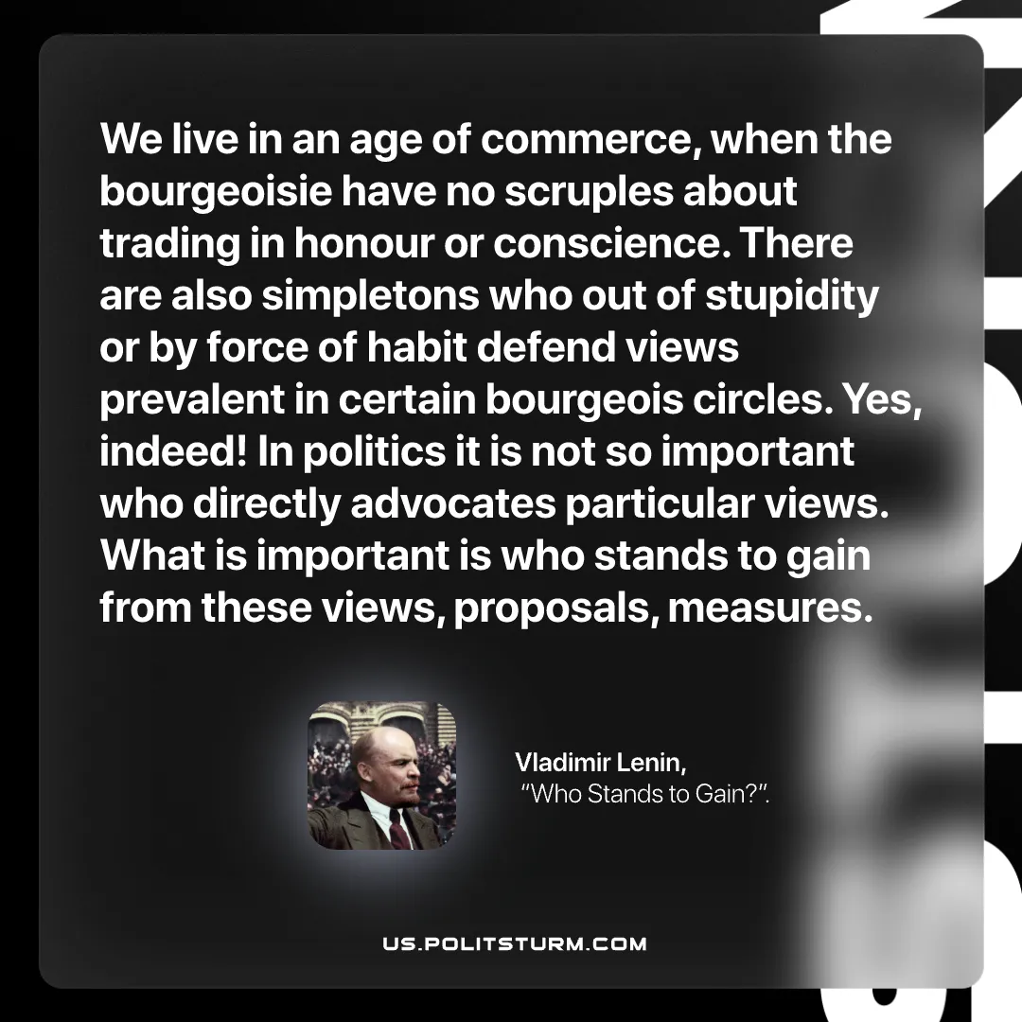

Original article
2026-07-12

We live in an age of commerce, when the bourgeoisie have no scruples about trading in honour or conscience. There are also simpletons who out of stupidity or by force of habit defend views prevalent in certain bourgeois circles. Yes, indeed! In politics it is not so important who directly advocates particular views. What is important is who stands to gain from these views, proposals, measures.
Vladimir Lenin, “Who Stands to Gain?”

Original article

