Lenin on fines
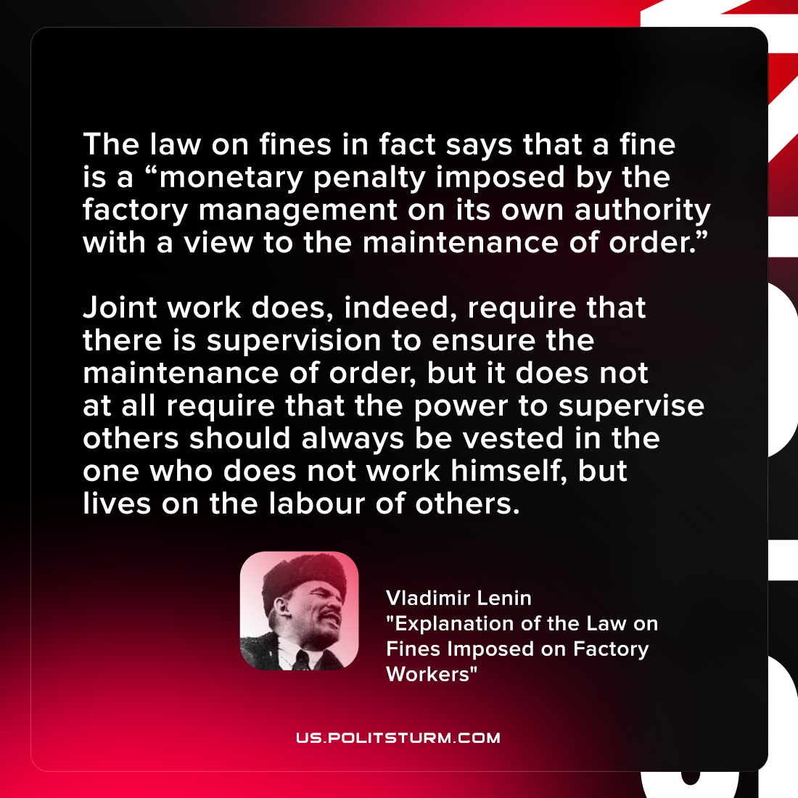

Original article
2021-09-26
1 min read

The law on fines in fact says that a fine is a “monetary penalty imposed by the factory management on its own authority with a view to the maintenance of order.”…Joint work does, indeed, require that there is supervision to ensure the maintenance of order, but it does not at all require that the power to supervise others should always be vested in the one who does not work himself, but lives on the labour of others.

Vladimir Lenin, “Explanation of the Law on Fines Imposed on Factory Workers”

Original article

