Lenin on Finance Capital
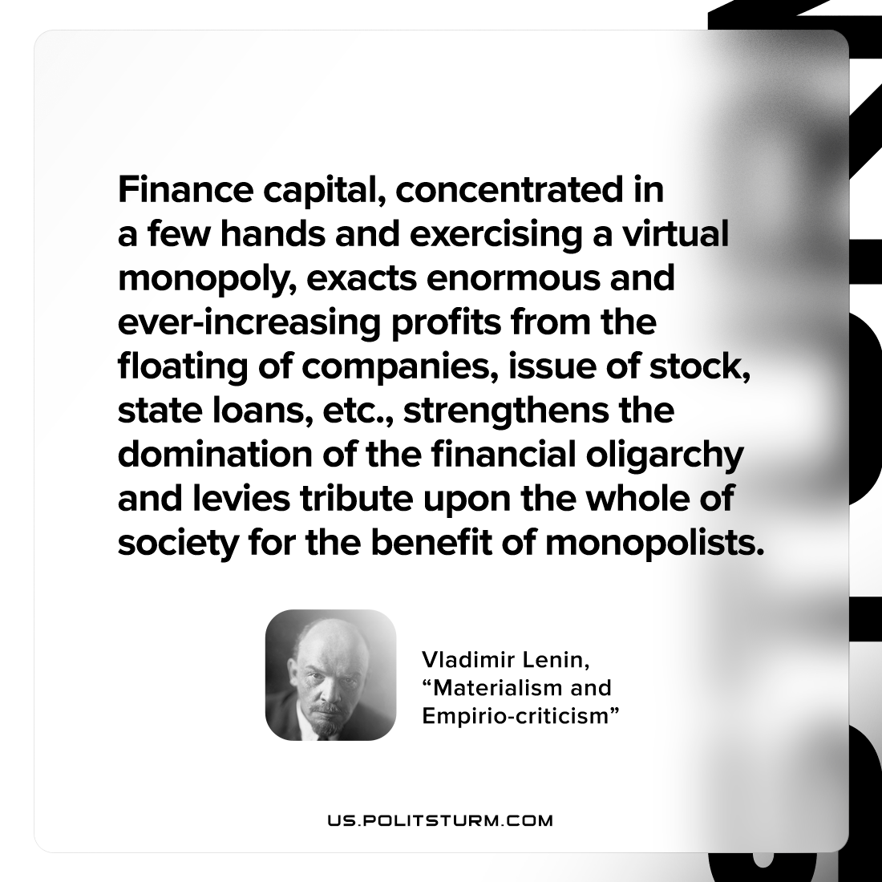

Original article
2022-07-31

Finance capital, concentrated in a few hands and exercising a virtual monopoly, exacts enormous and ever-increasing profits from the floating of companies, issue of stock, state loans, etc., strengthens the domination of the financial oligarchy and levies tribute upon the whole of society for the benefit of monopolists.

Vladimir Lenin, “Materialism and empirio-criticism”

Original article

