Lenin on Finance Capital and Financial Oligarchy
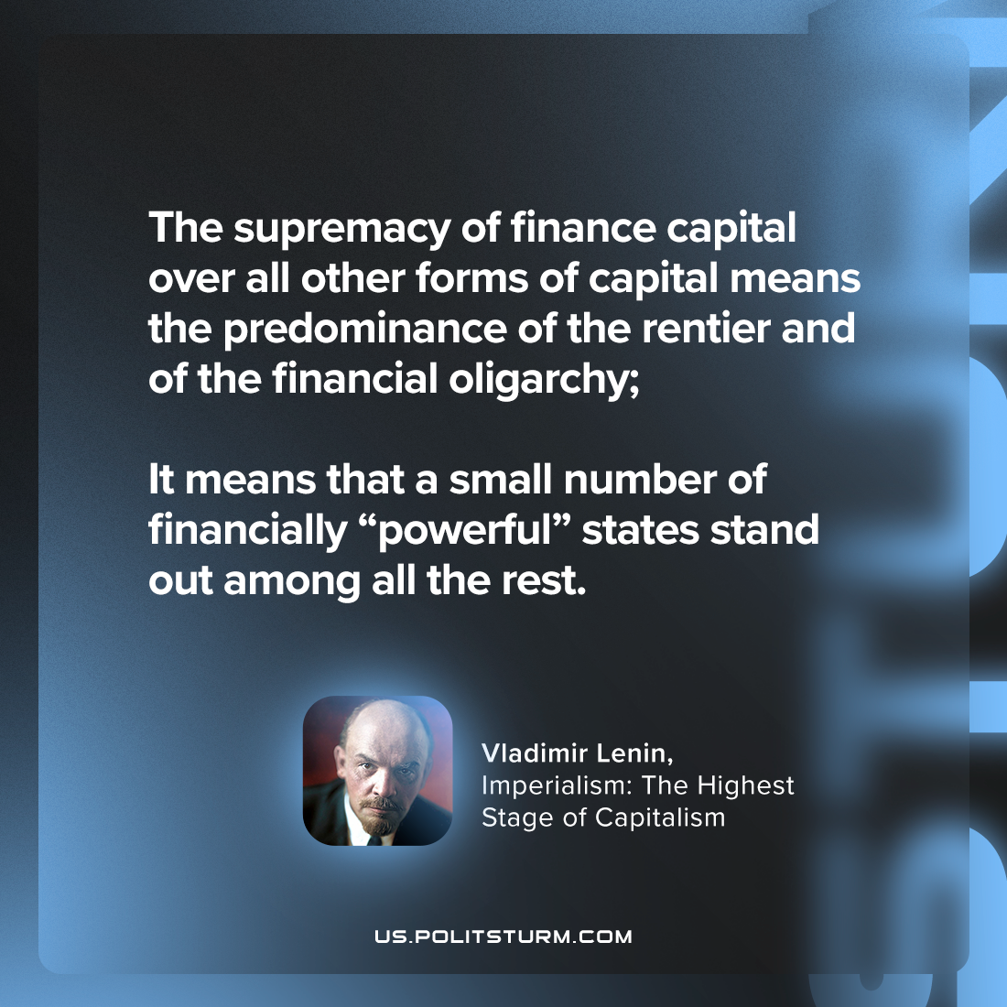

Original article
2023-10-22

"The supremacy of finance capital over all other forms of capital means the predominance of the rentier and of the financial oligarchy; it means that a small number of financially “powerful” states stand out among all the rest."
Vladimir Lenin, Imperialism: the Highest Stage of Capitalism

Original article

