Lenin on Finance Capital and Division of the World
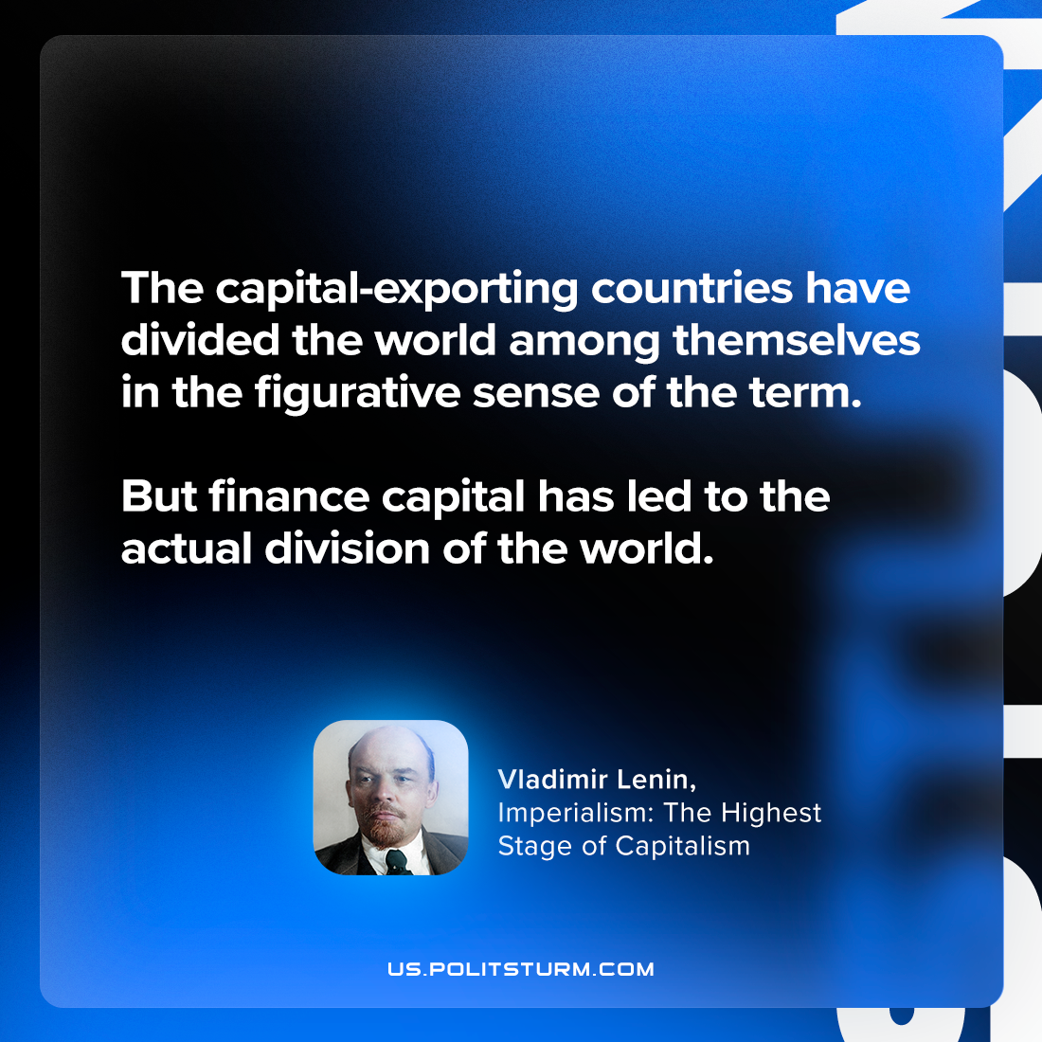

Original article
2023-10-15

"The capital-exporting countries have divided the world among themselves in the figurative sense of the term. But finance capital has led to the actual division of the world."
Vladimir Lenin, Imperialism: the Highest Stage of Capitalism

Original article

