Lenin on Fighting Religion
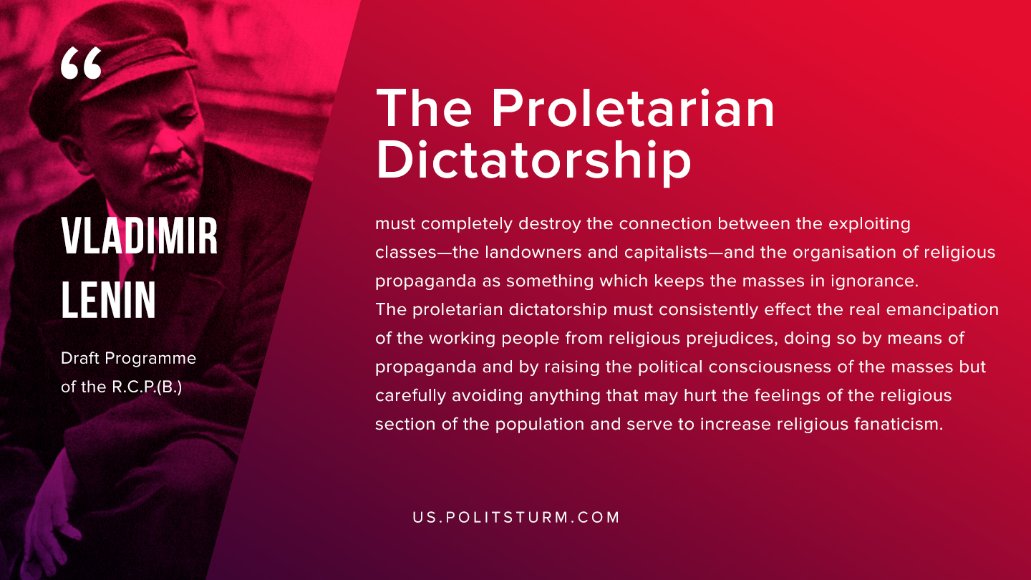

Original article
2019-09-20
1 min read

The proletarian dictatorship must completely destroy the connection between the exploiting classes—the landowners and capitalists—and the organisation of religious propaganda as something which keeps the masses in ignorance. The proletarian dictatorship must consistently effect the real emancipation of the working people from religious prejudices, doing so by means of propaganda and by raising the political consciousness of the masses but carefully avoiding anything that may hurt the feelings of the religious section of the population and serve to increase religious fanaticism.
Lenin, “Draft Programme of the R.C.P.(B)”

Original article

