Lenin on Facing the Truth
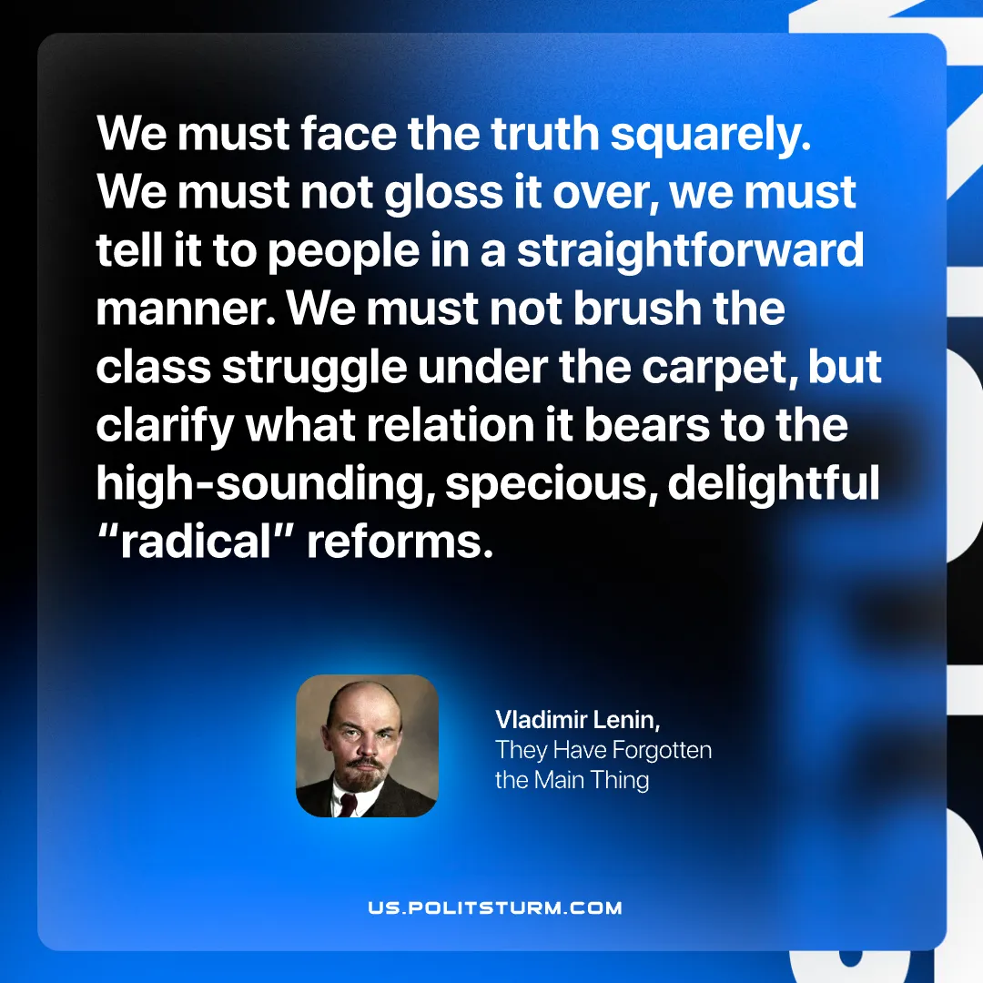

Original article
2026-09-01

Separated as it is from the people, forming a professional caste of men trained in the practice of violence upon the poor, men who receive somewhat higher pay and the privileges that go with authority (to say nothing of "gratuities"), the police everywhere, in every republic, however democratic, where the bourgeoisie is in power, always remains the unfailing weapon, the chief support and protection of the bourgeoisie.
Vladimir Lenin, They Have Forgotten the Main Thing

Original article

