Lenin on Extremes of Permanent Revolution
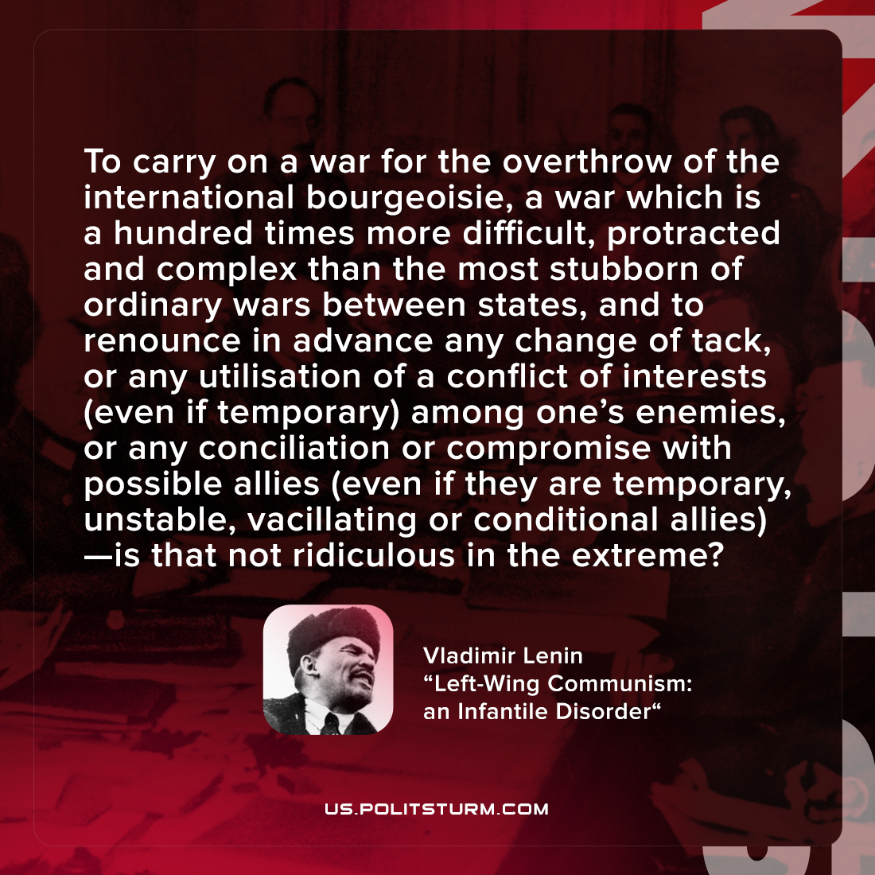

Original article
2022-01-15
1 min read

To carry on a war for the overthrow of the international bourgeoisie, a war which is a hundred times more difficult, protracted and complex than the most stubborn of ordinary wars between states, and to renounce in advance any change of tack, or any utilisation of a conflict of interests (even if temporary) among one’s enemies, or any conciliation or compromise with possible allies (even if they are temporary, unstable, vacillating or conditional allies)—is that not ridiculous in the extreme?

Vladimir Lenin, “Left-Wing Communism: an Infantile Disorder”

Original article

