Lenin on Export Capital
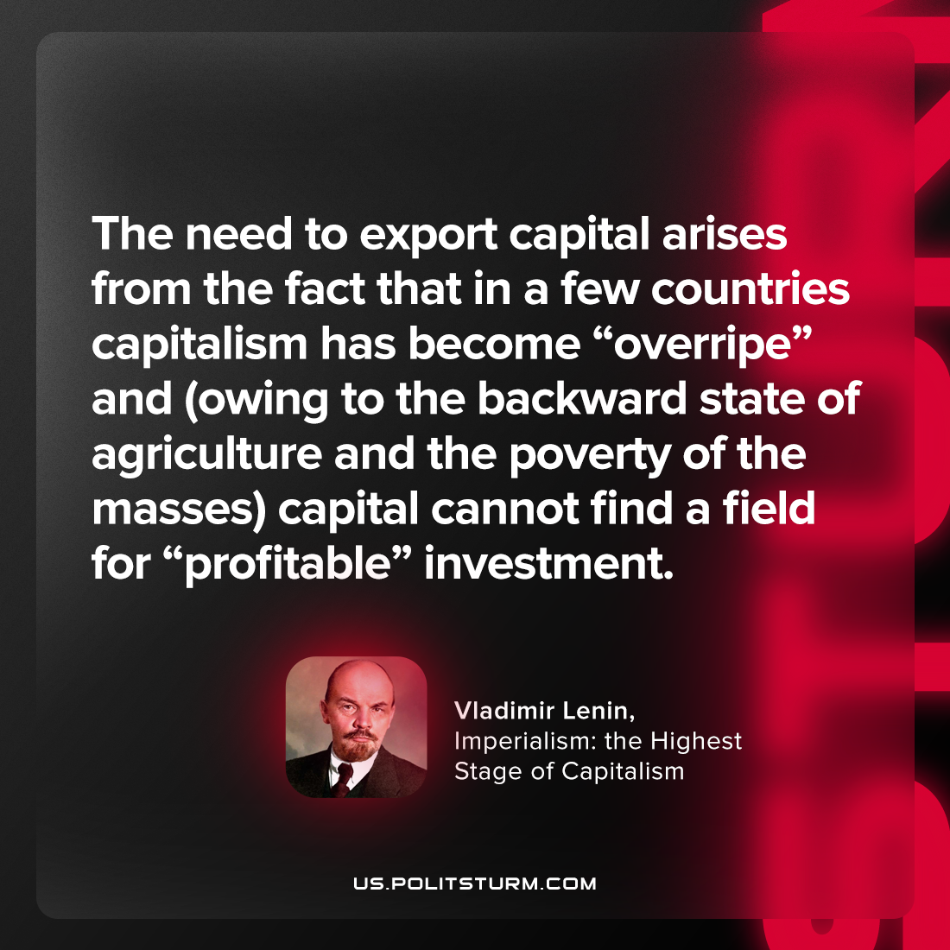

Original article
2023-07-30

"The need to export capital arises from the fact that in a few countries capitalism has become “overripe” and (owing to the backward state of agriculture and the poverty of the masses) capital cannot find a field for “profitable” investment."
Vladimir Lenin, Imperialism: the Highest Stage of Capitalism

Original article

