Lenin on Experience of the Proletarian Revolution
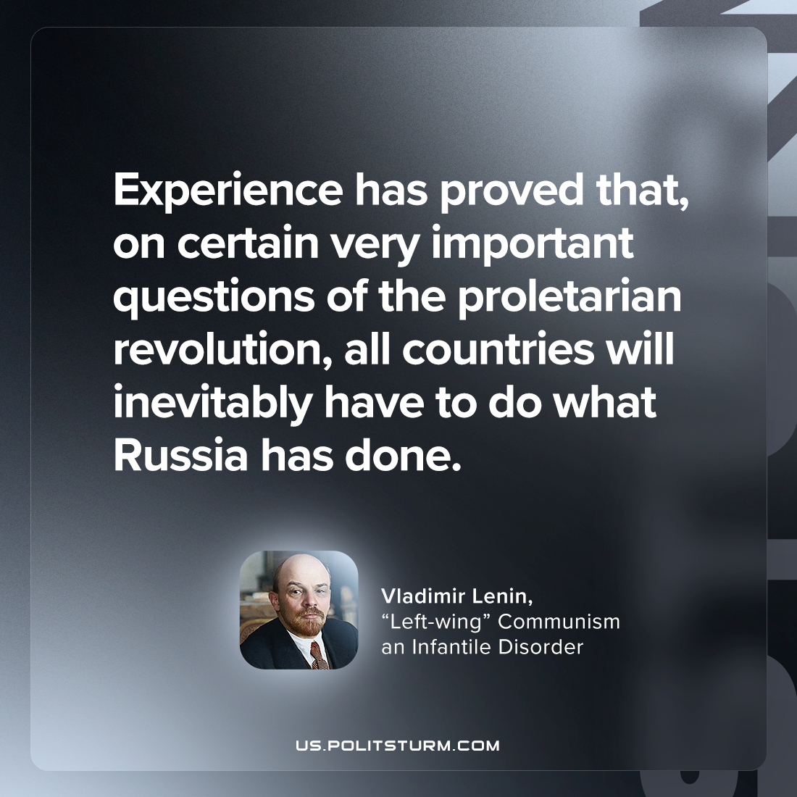

Original article
2023-10-17

"Experience has proved that, on certain very important questions of the proletarian revolution, all countries will inevitably have to do what Russia has done."
Vladimir Lenin, “Left-wing” Communism an Infantile Disorder

Original article

