Lenin on Equality
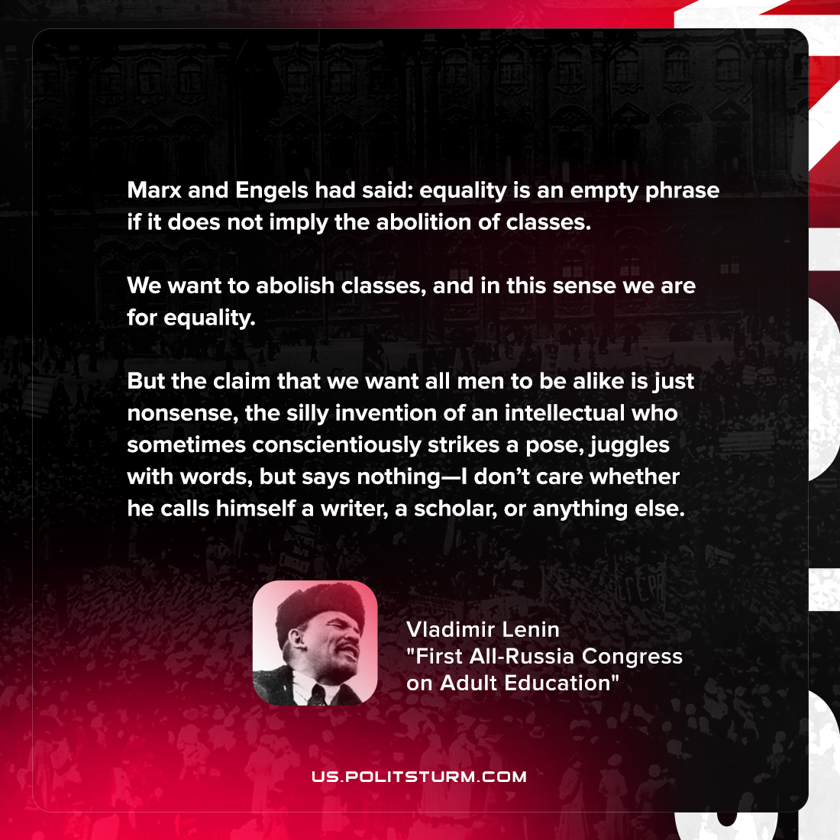

Original article
2021-10-09
1 min read

Marx and Engels—had said: equality is an empty phrase if it does not imply the abolition of classes. We want to abolish classes, and in this sense we are for equality. But the claim that we want all men to be alike is just nonsense, the silly invention of an intellectual who sometimes conscientiously strikes a pose, juggles with words, but says nothing—I don’t care whether he calls himself a writer, a scholar, or anything else.

Vladimir Lenin, “First All-Russia Congress on Adult Education”

Original article

