Lenin on Empty Bourgeois Reforms
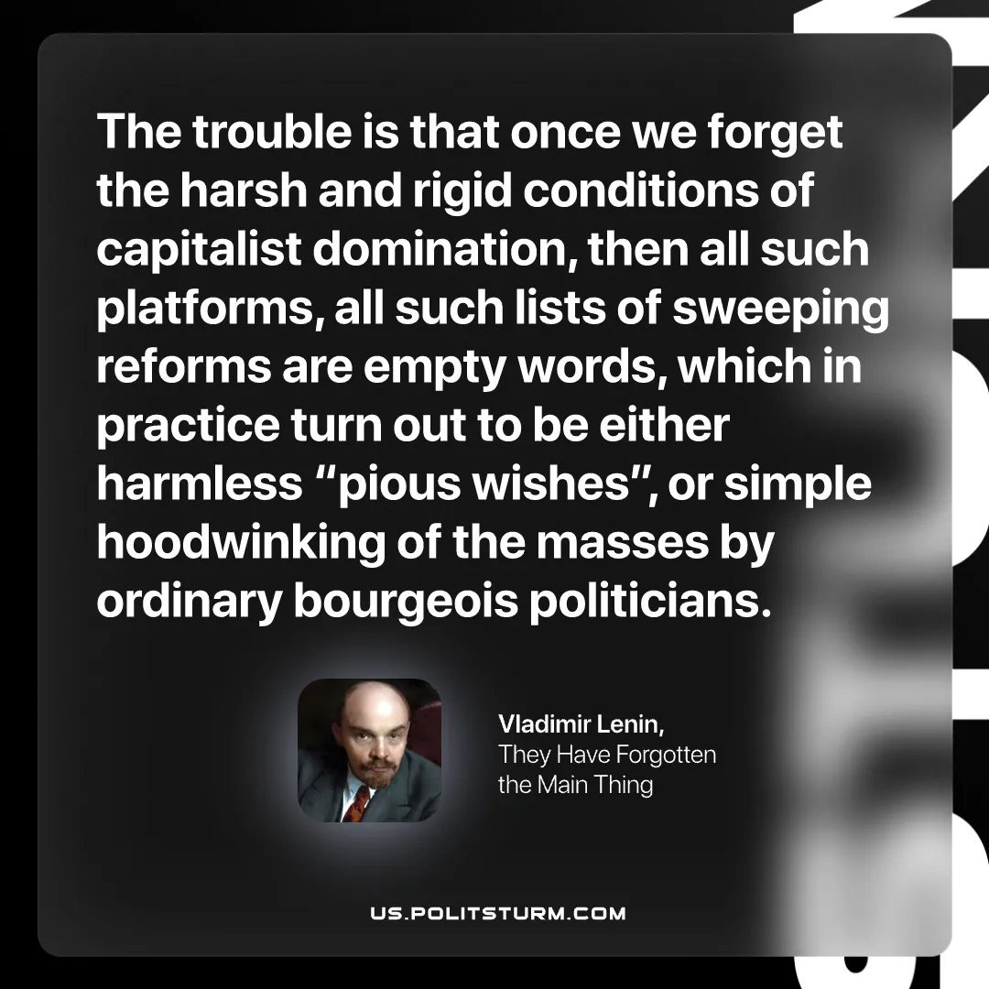

Original article
2026-08-29

The trouble is that once we forget the harsh and rigid conditions of capitalist domination, then all such platforms, all such lists of sweeping reforms are empty words, which in practice turn out to be either harmless "pious wishes", or simple hoodwinking of the masses by ordinary bourgeois politicians.
Vladimir Lenin, They Have Forgotten the Main Thing

Original article

