Lenin on Elections
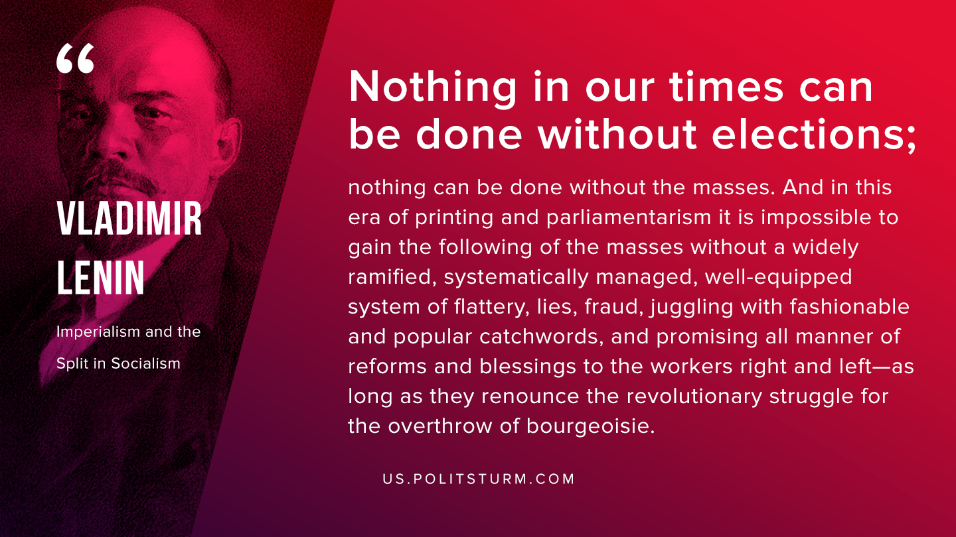

Original article
2020-02-02
1 min read

Nothing in our times can be done without elections; nothing can be done without the masses. And in this era of printing and parliamentarism it is impossible to gain the following of the masses without a widely ramified, systematically managed, well-equipped system of flattery, lies, fraud, juggling with fashionable and popular catchwords, and promising all manner of reforms and blessings to the workers right and left—as long as they renounce the revolutionary struggle for the overthrow of bourgeoisie.
V.I. Lenin, “Imperialism and the Split in Socialism”

Original article

