Lenin on Elections
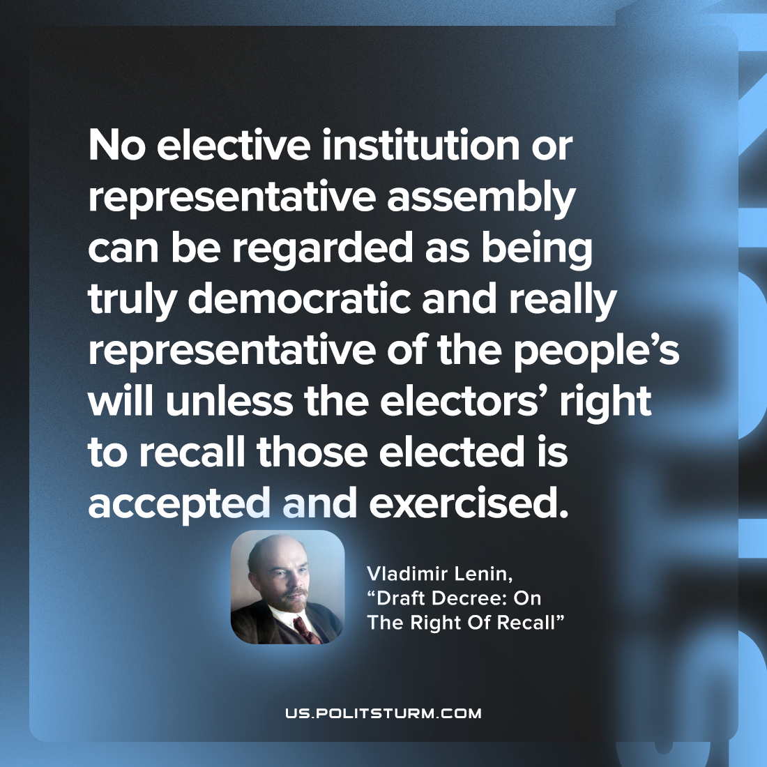

Original article
2022-08-18

No elective institution or representative assembly can be regarded as being truly democratic and really representative of the people’s will unless the electors’ right to recall those elected is accepted and exercised.

Vladimir Lenin, “Draft Decree: On The Right Of Recall”

Original article

