Lenin on Economic Programme
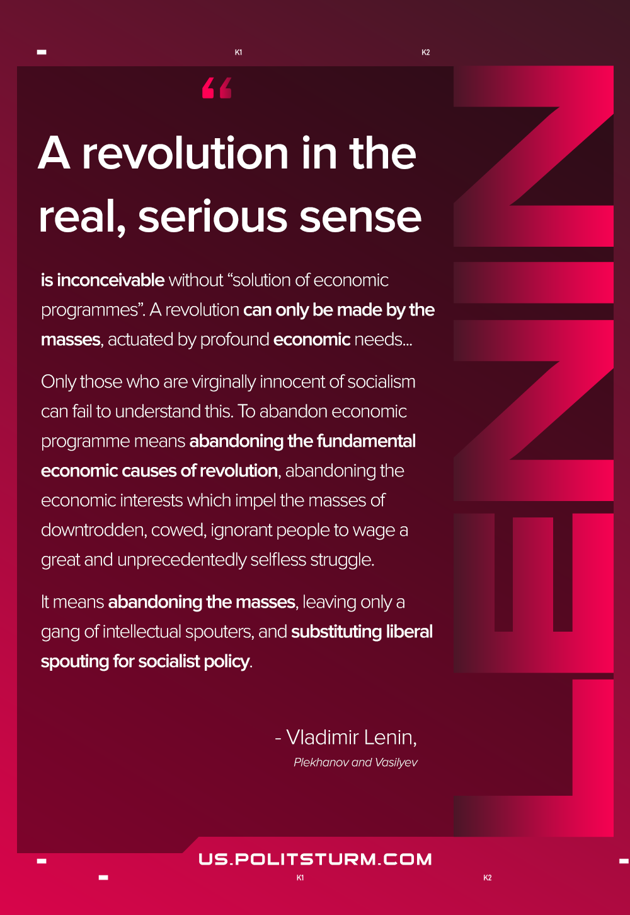

Original article
2021-01-21
1 min read

A revolution in the real, serious sense is inconceivable without “solution of economic programmes”. A revolution can only be made by the masses, actuated by profound economic needs. The fall of absolutism in Russia, its real fall, would inevitably mean an economic revolution. Only those who are virginally innocent of socialism can fail to understand this. To abandon economic programme means abandoning the fundamental economic causes of revolution, abandoning the economic interests which impel the masses of downtrodden, cowed, ignorant people to wage a great and unprecedentedly selfless struggle. It means abandoning the masses, leaving only a gang of intellectual spouters, and substituting liberal spouting for socialist policy.
Vladimir Lenin, “Plekhanov and Vasilyev”

Original article

