Lenin on Dictatorship of Proletariat and Communist Party
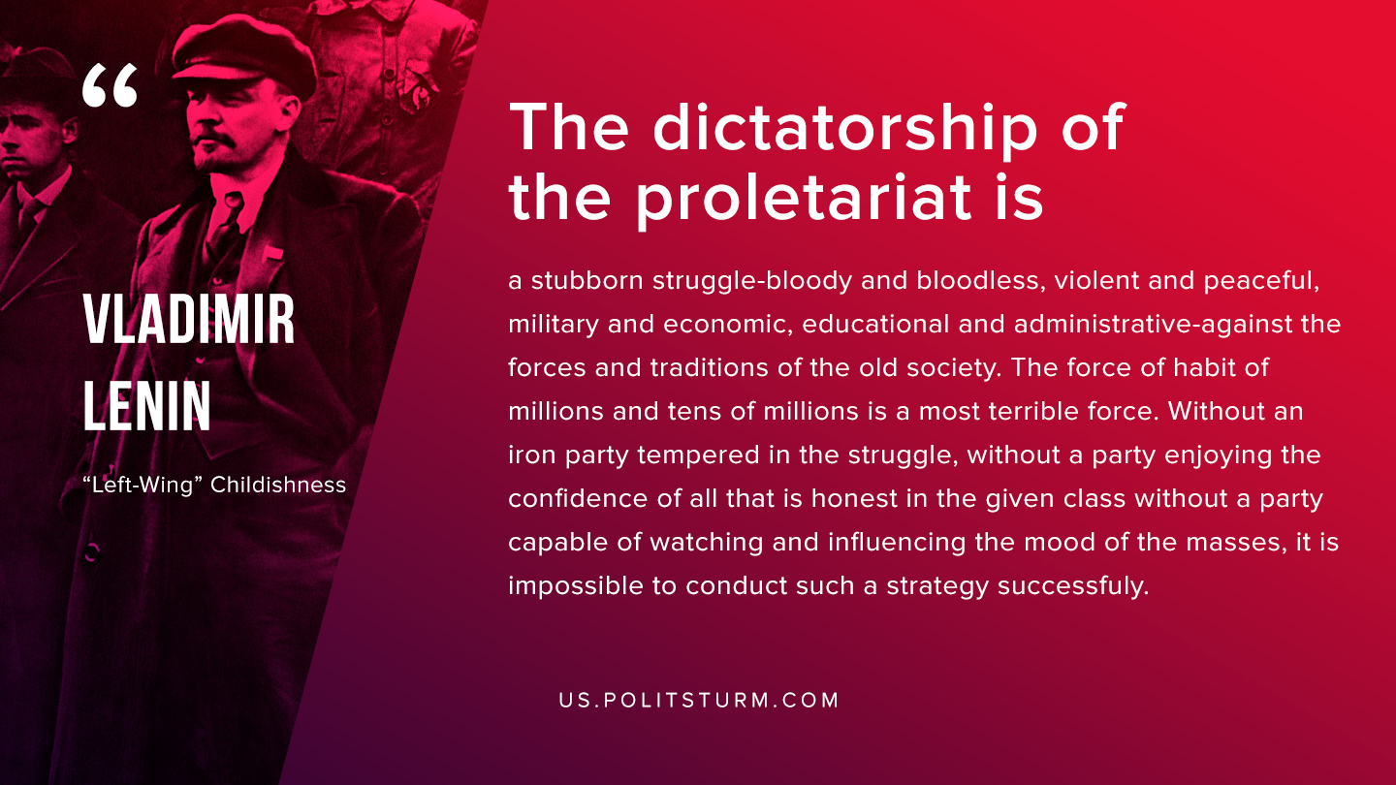

Original article
2019-08-03
1 min read

The dictatorship of the proletariat is a stubborn struggle-bloody and bloodless, violent and peaceful, military and economic, educational and administrative-against the forces and traditions of the old society. The force of habit of millions and tens of millions is a most terrible force. Without an iron party tempered in the struggle, without a party enjoying the confidence of all that is honest in the given class without a party capable of watching and influencing the mood of the masses, it is impossible to conduct such a strategy successfully.
V.I. Lenin “Left-Wing” Childishness

Original article

