Lenin on "Democratic" Peace and Class Struggle
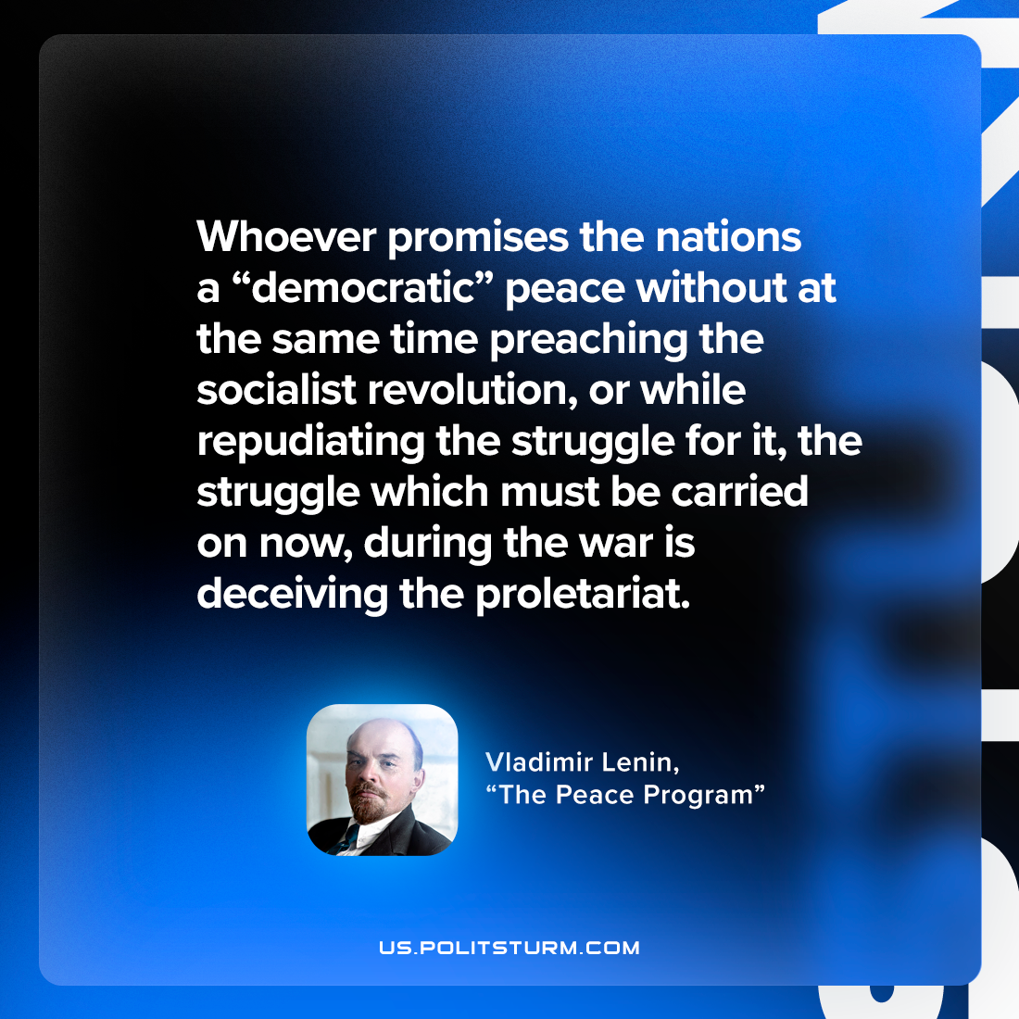

Original article
2023-04-01

"Whoever promises the nations a “democratic” peace without at the same time preaching the socialist revolution, or while repudiating the struggle for it—the struggle which must be carried on now, during the war—is deceiving the proletariat."
Vladimir Lenin, “The Peace Programme”

Original article

