Lenin on Democratic Control
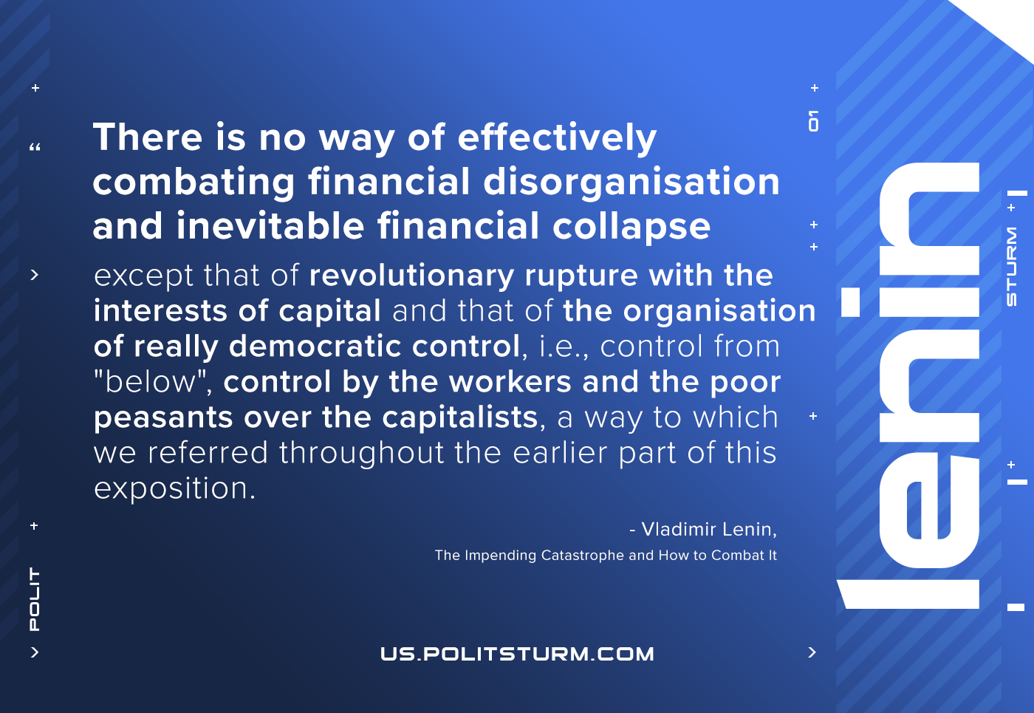

Original article
2021-01-19

There is no way of effectively combating financial disorganization and inevitable financial collapse except that of revolutionary rupture with the interests of capital and that of the organization of really democratic control, i.e., control from “below”, control by the workers and the poor peasants over the capitalists, a way to which we referred throughout the earlier part of this exposition.
Vladimir Lenin, “The Impending Catastrophe and How to Combat It”

Original article

