Lenin on Democracy Under Capitalism
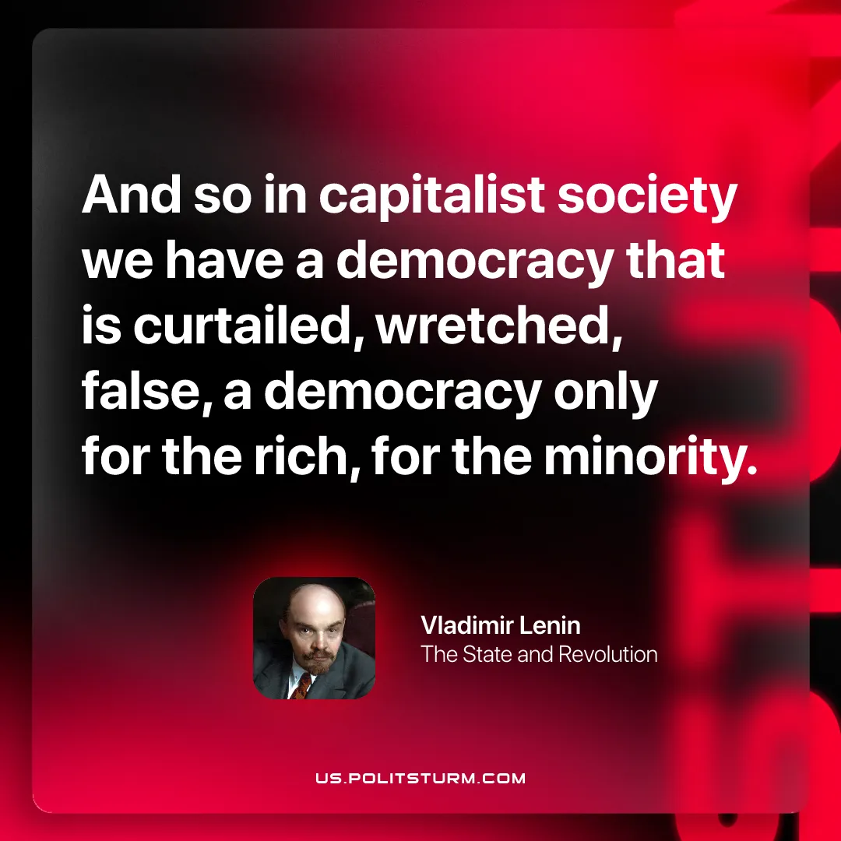

Original article
2026-02-01

“And so in capitalist society we have a democracy that is curtailed, wretched, false, a democracy only for the rich, for the minority.”
Vladimir Lenin, The State and Revolution

Original article

