Lenin on Democracy as a Form of State
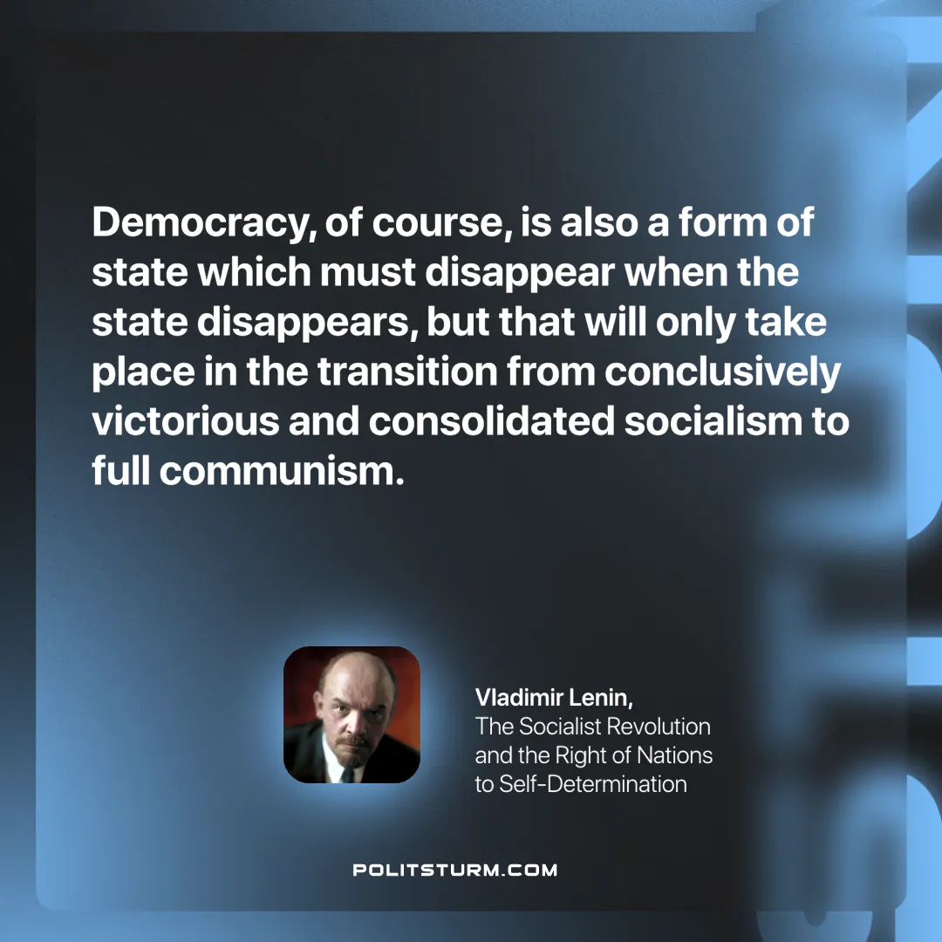

Original article
2025-06-15

“Democracy, of course, is also a form of state which must disappear when the state disappears, but that will only take place in the transition from conclusively victorious and consolidated socialism to full communism.”
Vladimir Lenin, The Socialist Revolution and the Right of Nations to Self-Determination

Original article

