Lenin on Democracy and Communism
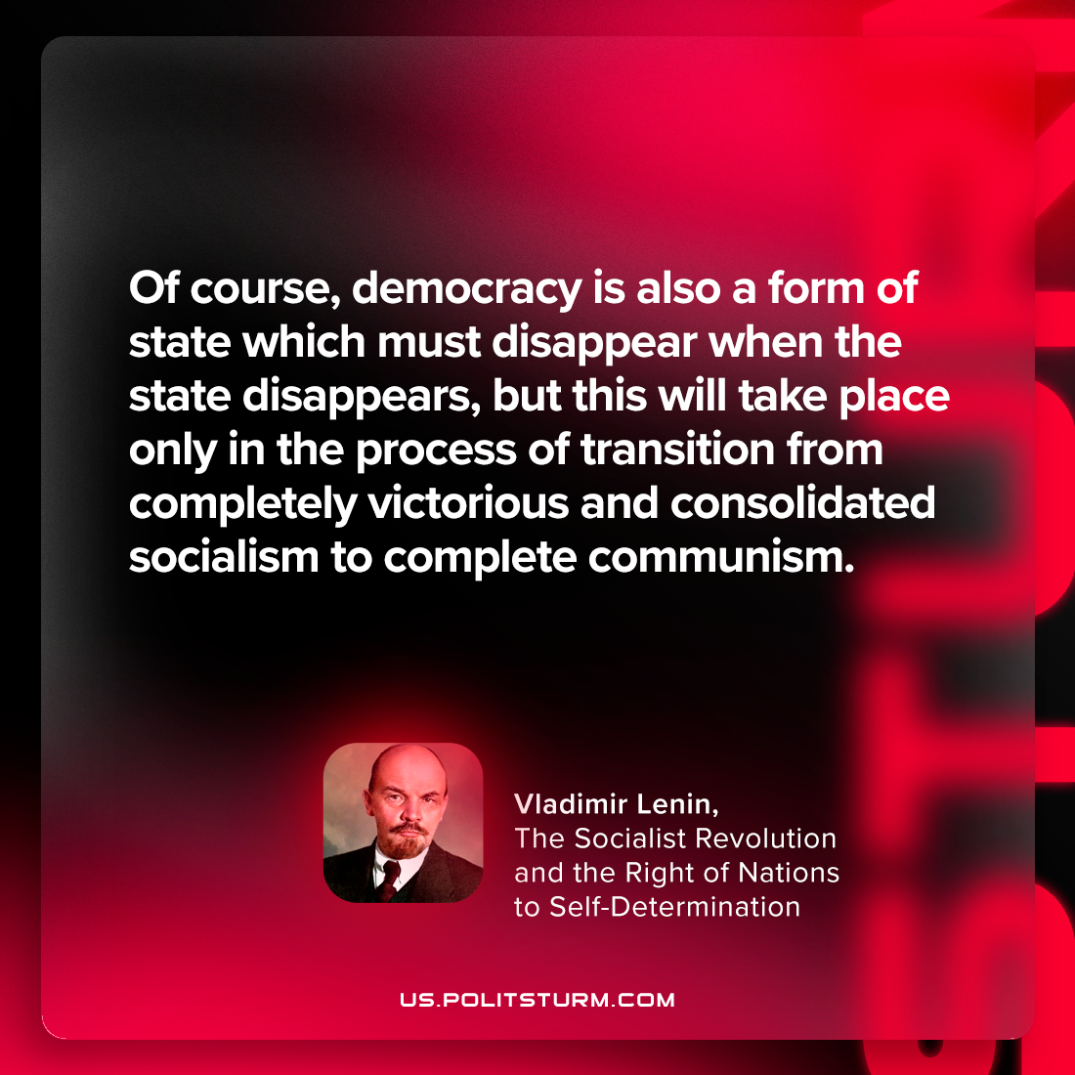

Original article
2024-03-26

“Of course, democracy is also a form of state which must disappear when the state disappears, but this will take place only in the process of transition from completely victorious and consolidated socialism to complete communism.”
Vladimir Lenin, The Socialist Revolution and the Right of Nations to Self-Determination

Original article

