Lenin on Demagogues
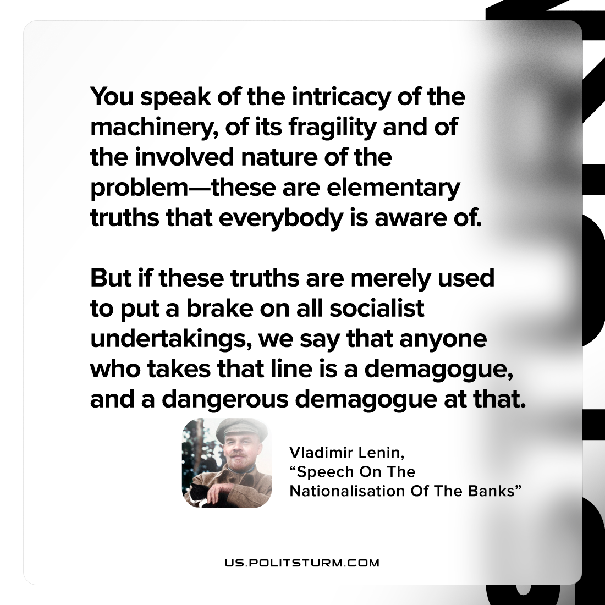

Original article
2022-08-16

You speak of the intricacy of the machinery, of its fragility and of the involved nature of the problem—these are elementary truths that everybody is aware of. But if these truths are merely used to put a brake on all socialist undertakings, we say that anyone who takes that line is a demagogue, and a dangerous demagogue at that.

Vladimir Lenin, “Speech On The Nationalisation Of The Banks”

Original article

